3-D Stages of Firing Poster (Poster 1)
Step 1: Read the information provided about Stages of Firing (on website)
Step 2: Using PicCollage, to create your poster with original photos
Step 3: Satisfy these requirements:
 | A | B | C | D-F
Design & Color | The posters feature a specific set of colors to tie everything together. The poster is arranged in a way that makes the information easily accessible. | The posters feature a specific set of colors to tie everything together. The poster is mostly arranged in a way that makes the information easily accessible. | The posters do not really feature a specific set of colors to tie everything together. The poster is somewhat arranged in a way that makes the information easily accessible. | The posters do not feature a specific set of colors to tie everything together. The poster is not arranged in a way that makes the information easily accessible.
Summarization | The posters feature excellent summarization of key steps and terms without skipping too many important details. | The posters feature good summarization of key steps and terms without skipping too many important details. | The posters feature adequate summarization of key steps and terms but skip some important details. | The posters feature poor summarization of key steps and terms and skip too many important details.
Spelling, Grammar, Capitalization | The posters have correct spelling, grammar, and capitalization | The posters mostly have correct spelling, grammar, and capitalization | The posters have some correct spelling, grammar, and capitalization | The posters have little correct spelling, grammar, and capitalization
Images | The posters display 3 or more images specific to clarifying concepts presented in the summarization. | The posters display 3 or more images mostly specific to clarifying concepts presented in the summarization. | The posters display 3 or more images somewhat specific to clarifying concepts presented in the summarization. | The posters display 3 or more images not specific to clarifying concepts presented in the summarization.
Step 4: After completing your Poster, click the box with the arrow in it in the bottom right-hand corner. Save your poster to the Photo Library.
Step 5: Open Photos and Print.

3-D Ceramics Aesthetics Poster (Poster 2)
Step 1: Choose a photo of a ceramic piece (on website)
Step 2: Using PicCollage, create a poster that features the photo of the ceramic piece and also includes the Elements, Principles, and Expression of the piece (see example)
Step 3: Satisfy these requirements:
 | A | B | C | D-F
Design & Color | The posters feature a specific set of colors to tie everything together. The poster is arranged in a way that makes the information easily accessible. | The posters feature a specific set of colors to tie everything together. The poster is mostly arranged in a way that makes the information easily accessible. | The posters do not really feature a specific set of colors to tie everything together. The poster is somewhat arranged in a way that makes the information easily accessible. | The posters do not feature a specific set of colors to tie everything together. The poster is not arranged in a way that makes the information easily accessible.
Summarization  Spelling, Grammar, Capitalization | The posters feature excellent summarization of elements principles and terms without skipping too many important details.  The posters have correct spelling, grammar, and capitalization | The posters feature good summarization of elements principles and terms without skipping too many important details.  The posters mostly have correct spelling, grammar, and capitalization | The posters feature adequate summarization of elements principles and terms but skip some important details.  The posters have some correct spelling, grammar, and capitalization | The posters feature poor summarization of elements principles and terms and skip too many important details.  The posters have little correct spelling, grammar, and capitalization
Step 4: After completing the Poster, click the box with the arrow in it in the bottom right-hand corner. Save your poster to the Photo Library.
Step 5: Open Photos and Print.

3-D Ceramic Aesthetics (info for Poster 2)
Elements  Shape & Form:  As you look at the pot’s profile or silhouette, how would you describe it as a two-dimensional shape? Is it geometric or organic or a combination of both? Now look at the pot’s three-dimensional form. Is it a cube, a pyramid, a cylinder, or a combination of forms? Now look at the parts (foot, body, neck). How would you describe their forms? How do they relate to one another?  Line:  Lines can be described according to their width (thick, thin, tapering), length, and characteristics (sharp, fuzzy, continuous, or broken). Do the lines of the pot suggest movement (circulating, flowing) and direction (curving, horizontal, vertical, diagonal, parallel)? Do they have boundaries or edges?  Space:  Is the space between the walls of the pot enclosed or open, deep, or shallow? Can you locate areas of positive and negative space? (An example of negative space is the empty space enclosed within the handle of a cup)  Texture:  How would you describe the surface (rough or smooth, ridged, pebbly, or grooved)? If the surface shows relief, is it high, low, or sunken? Are shadows part of the textural surface? Is light reflected or diffused? Does the texture vary in different areas of the work? | Principles  Balance:  Review your list of the pot’s elemental qualities. How are they organized to achieve balance? For example, imagine a vertical line through the center of the pot. Are the sides balanced? How do shape, line, texture, and other deign elements contribute to the balance? Would you describe the piece as symmetrical (left and right sides are mirror images of each other) or asymmetrical (sides appear different)? Now imagine a line through the horizontal center of the piece. How would you describe the balance between the top and bottom?  Unity:  How do the forms of the parts (foot, body, neck, shoulder) contribute to the overall form of the pot? How does the surface decoration of the pot, including texture and shape work to make the pot seem whole? Are the parts harmonious?  Proportion & Size:  What words would you use to describe the size of the object? Consider words like length, height, width, volume, weight, thickness? Does the work have typical proportions for a functional object (for example, could you easily drink coffee out of a cup like this, by holding its handle), or is it more of a sculptural form (a miniature cup or a giant cup) because of its unusual proportions?  Movement & Rhythm:  Locate and describe any repeated qualities, themes, or designs. Are they repeated in the same way each time or are they varied? Elaborate. Any repeated element contributes to the visual flow and rhythm in each area of the piece. For example, when using lines, a series of crosshatching on the body of a pot could slow down visual movement, whereas a horizontal line around the body could increase its speed. Locate any slow or fast areas on the pot. Describe them and explain why you think they are slow or fast. What rhythms do they create?  Emphasis:  Sometimes one area grabs your attention more than another—a design, some textural relief, an area of color, or even a major theme that tells a story. Find and describe dominant area(s) in the example and tell how the artist organized the elements to achieve that emphasis. Emphasis can also be achieved through the use of simplicity.  Pattern:  Are patterns in this work random or planned? Are they the result of repeated lines, shapes, or textures? How would you describe the patterns and where they appear? Consider words like radial, grid, alternating, border or band. What contrasts are formed by the use of pattern? | Expression  Mood:  How can you describe the feeling you get from looking at he clay work? Base your answer on the elements and principles you discovered. Think about mood words like happy, witty, whimsical, playful, clumsy, mysterious, reflective, calm, quiet, etc.  Tension:  How do the elements and principles you’ve noted give a sense of the clay work’s energy? Describe that state. Consider words like tranquil, dynamic, powerful, lumpish, relaxed, conflicting, stonelike, heavy.  Ideals:  Sometimes a work seems to express an ideal. Some words that signify those qualities are heroic, majestic, noble, humble, authoritative, regal.  Process:  How was the object formed? Explain the method of construction (slab, pinch, coil, thrown, combination).  Decoration:  What decorative technique was used on the clay work’s surface? Use words like incise, carve, paint, wax resist, burnish, inlay, glaze colors.
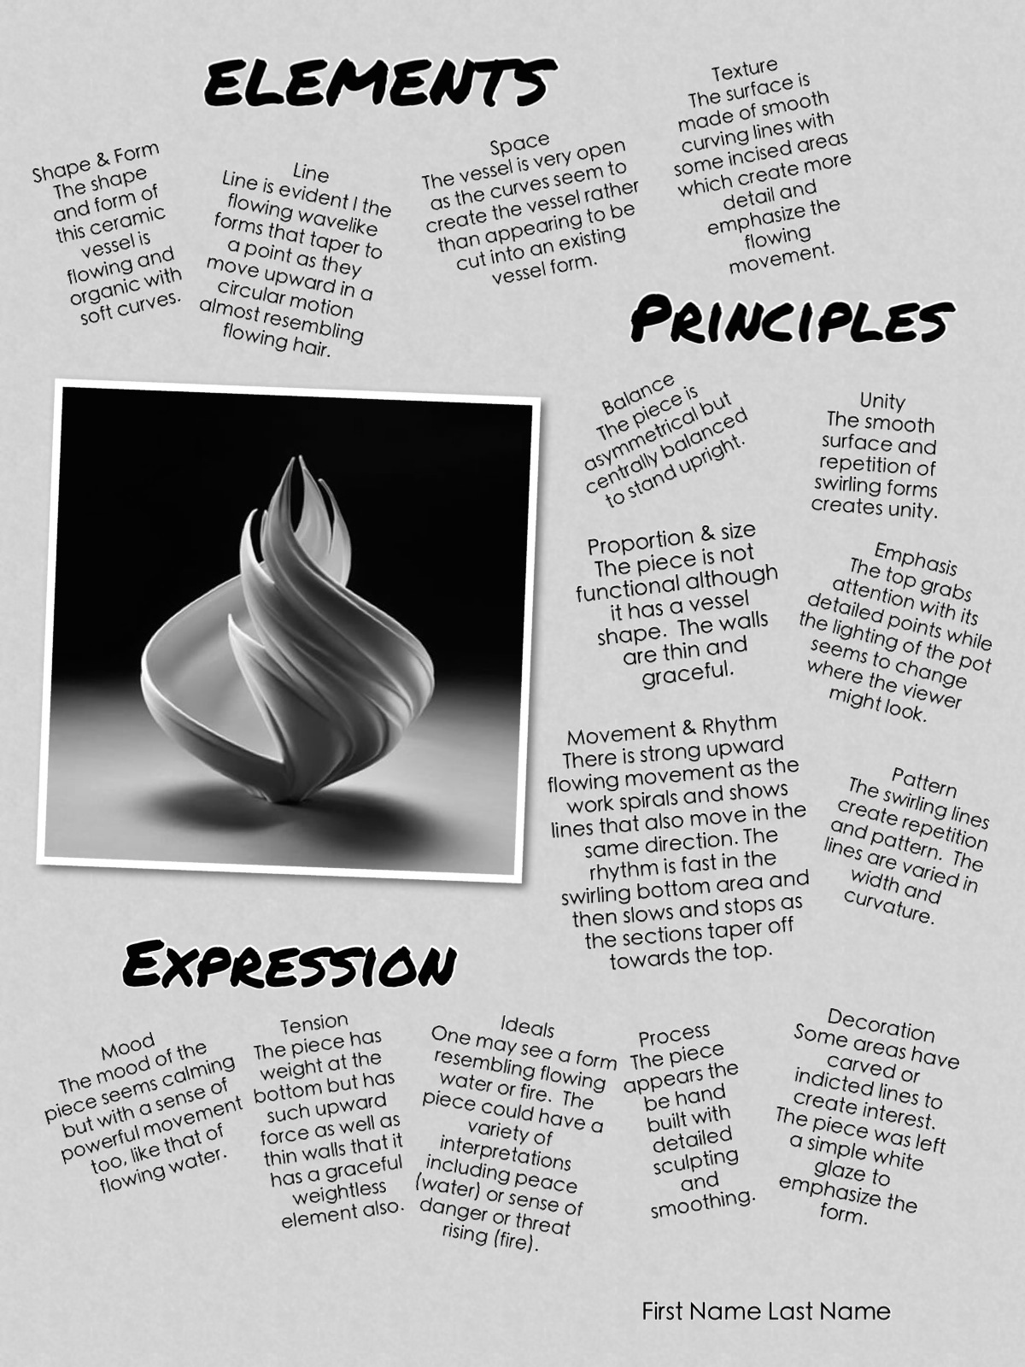Example of Poster 2

