4 Logos: Target Audience

What is the final product?
You will choose one object to create 4 logos. The 4 logos will each be targeted to a different audience: child, teen, adult, elderly and will therefore incorporate different styles and colors.

Step One:
Choose an easily recognizable object such as: light bulb, key, alarm clock, fork & spoon, leaf, piggy bank, etc.
You will be using this object to design a logo. The logo will consist of an image of the object and the name of the object.

Step Two:
Complete your planning packet. You will need two sheets of paper for each of the 4 logos:

- Paper 1: Logo Planning Sheet—research on the internet to find examples of successful child (or teen, adult, elderly) logos. Collect images of your item that might help you style your logo. Collect any fonts that may be useful. Note any colors or stylistic items you want to include.
You will then SKETCH at least 2-3 original logo ideas.

- Paper 2: Sheet of image research from the internet: images of successful logos, object images, etc. (EVIDENCE)

Step Three:
You will design a total of 4 logos, one for each of these 4 target audiences: child, teen, adult, elderly. Consider photographing your sketches and working with them in Illustrator.
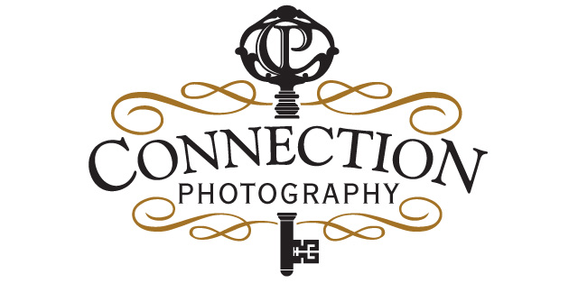
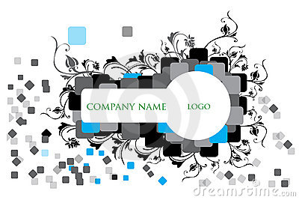
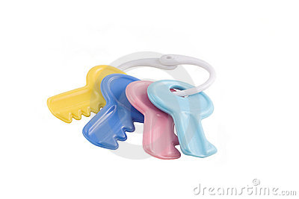

4 Logos Rubric

 | A | B | C | D-F
Illustrator Technique | A variety of tools were used to create the piece. Graphics are clear and shapes drawn with the pen tool are seamlessly crafted. | A variety of tools were used to create the piece. Graphics are clear and shapes drawn with the pen tool are mostly seamlessly crafted. | Some variety of tools were used to create the piece. Graphics are clear and shapes drawn with the pen tool are decently crafted. | Little variety of tools were used to create the piece. Graphics are not clear and shapes drawn with the pen tool are not well crafted.
Design/ Elements of Art | The design is fully balanced and carefully uses Line, shape, color, value, texture, space, and form AND contrast, repetition, alignment, and proximity. | The design is balanced and carefully uses Line, shape, color, value, texture, space, and form AND contrast, repetition, alignment, and proximity. | The design is somewhat balanced and uses Line, shape, color, value, texture, space, and form AND contrast, repetition, alignment, and proximity. | The design is not balanced and does not Line, shape, color, value, texture, space, and form AND contrast, repetition, alignment, and proximity.
Attention to Target Audience | The outstanding detail in color and style is supportive of the target audience’s taste. | The detail in color and style is supportive of the target audience’s taste. | The detail in color and style is somewhat supportive of the target audience’s taste. | The detail in color and style is not supportive of the target audience’s taste.
Planning Packet | The planning packet was fully completed with outstanding quality sketches and research. | The planning packet was fully completed with quality sketches and research. | The planning packet was mostly completed with quality sketches and research. | The planning packet was not fully completed with quality sketches and research.

