Visual Communications:
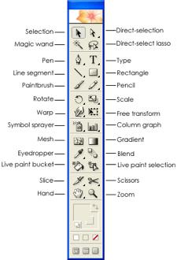
Adobe Illustrator CS2 Toolbar

