Name: _____________________
Abstract Guitar Sculpture
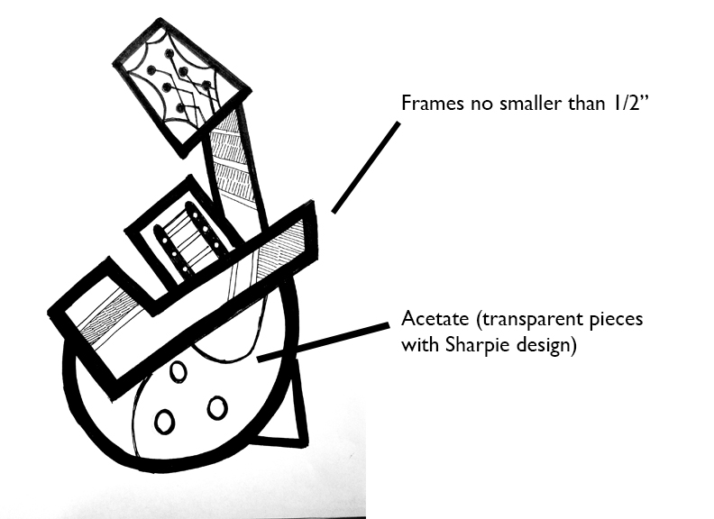
Design
- Use an 8/5 x 11 sheet of paper to design an abstract guitar.
  - Use a combination of guitars and abstract artwork to influence your design.
  - Look for ways to repeat shapes to create a cohesive design.
- Your shapes are “frames.” Within each frame is a piece of acetate (plastic) which you can use sharpie to add additional design.

Construction
- Use graphite to transfer shapes of your individual pieces. Cut out frames with an X-acto knife.
- Trace your frame again to create the back side.
- Trace the outside of your frame on acetate. Cut slightly smaller. Add sharpie designs.
- Paint frames with black acrylic on both sides AND on the edges (painting both sides helps hide the frames being slightly different sizes)
- Assemble your frames, sandwiching your acetate in between and seal with glue.
- Assemble your frames to create your whole piece……Add depth……
You need at least a 2 inch width to your project.

Rubric
 | A | B | C | D-F
Design, Balance, Form | The design was carefully thought through with interesting details and repetition and attention to asymmetrical balance. There is careful attention to design as far as three dimensional form. | The design was mostly carefully thought through with interesting details and repetition and attention to asymmetrical balance. There is attention to design as far as three dimensional form. | The design was somewhat thought through with some details and repetition and attention to asymmetrical balance. There is some attention to design as far as three dimensional form. | The design was not carefully thought through with few details and little repetition and little to no attention to asymmetrical balance. There little attention to design as far as three dimensional form.
Craftsmanship | Frames are painted completely black. There is no sign of glue or rough edges. All lines are drawn or cut neatly. | Frames are painted completely black. There is little to no sign of glue or rough edges. All lines are drawn or cut neatly. | Frames are painted mostly completely black. There is little to no sign of glue or rough edges. Lines are drawn or cut neatly. | Frames are not painted completely black. There is excessive glue or rough edges. Lines are not drawn or cut neatly.

