“Afterimage” Still Life
Name :_____________________________
[af-ter-im-ij, ahf-] noun
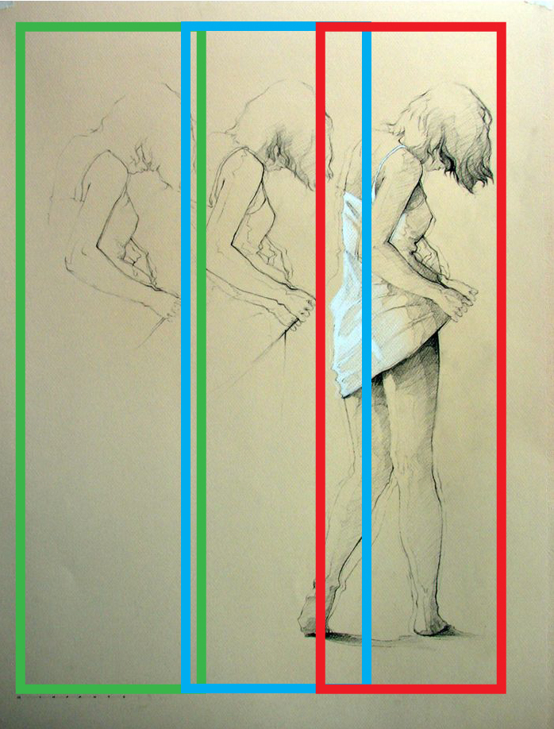
- a sustained or renewed sensation, especially visual, after the original stimulus has ceased

In this assignment, you will be creating a still life composition with an “afterimage.” The media will be colored pencil on chipboard.

Use a viewing frame to select an area of the still life. Sketch this section on 5”x 20” (or 7 x 14) paper.

Trace or transfer this sketch onto TWO sheets of 5” x 20” (or 7 x 14) paper.

RED The original drawing will be transferred* to your chipboard. You will render this drawing using colored pencil. The image will fade at the top and bottom. You will use full color to render the image but NO BLACK. Create darker tones with complementary colors. YOU WILL NEED A COLOR SCHEME: ___________________

BLUE On one of your two 5” x 20” copies, you will create a line drawing with variation in linear weight. Take away some of the original drawing and use some minimal shading to hint at the first image. This will be transferred* to the chipboard and rendered with 1-3 colored pencils.

GREEN On the last of your two copies, take a way more of the image, keep variation in linear weight and do not shade. This will be transferred* to the chipboard and rendered with 1-2 colored pencils.

*When you transfer, you may overlap the images slightly.

 | A | B | C | D-F
Drawing | Everything is rendered in proportion and perspective with attention to variation in line. | Mostly everything is rendered in proportion and perspective with attention to variation in line. | Many areas are rendered in proportion and perspective with some attention to variation in line. | Very little is rendered in proportion and perspective. There is little attention to variation in line.
Color & Value | There is a full range of value and careful use of color scheme and complementary colors. | There is a good range of value and careful use of color scheme and complementary colors. | There is a good range of value and some use of color scheme and complementary colors. | There is not a full range of value and little to no use of color scheme and complementary colors.
Overall Effect | There is careful balance of line, shape, and color to create a completed piece fully utilizing the elements and principles. | There is balance of line, shape, and color to create a completed piece utilizing the elements and principles. | There is some balance of line, shape, and color to create a completed piece utilizing the elements and principles. | There is little balance of line, shape, and color to create a completed piece There is little utilization the elements and principles.

ART
SHORT RESPONSE QUESTIONS

- Restate the question
- Answer the question
- Cite specific examples/evidence
- Explain the evidence
- Sum it up

Name: ____________________________

Line Weight: When to Vary it and Why?
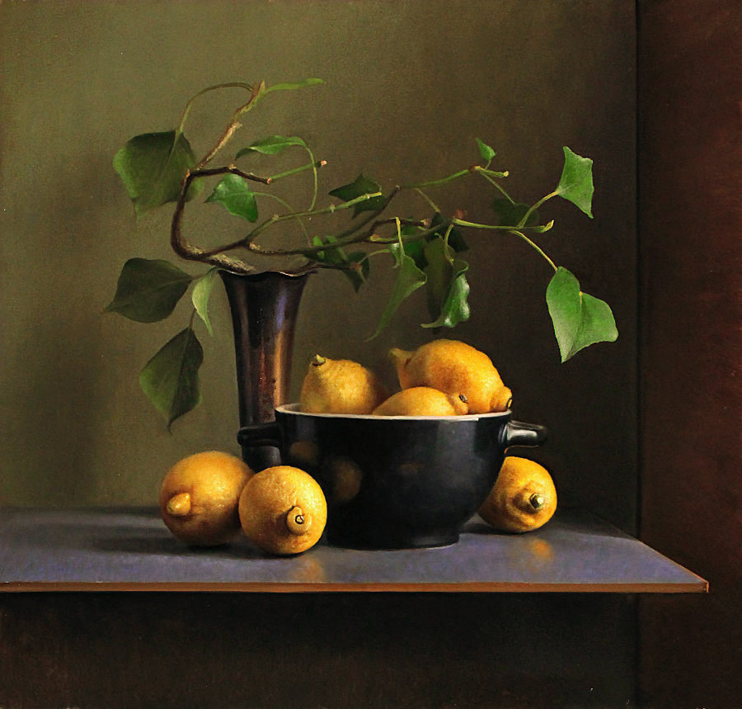
Lines contain information. There are some classical rules to the variation in line. One is that you use a thicker line for the “meat” and thinner line for the “bone” (mass). With this rule, the artist uses thicker lines for areas that are bulky, heavy, or solid and thinner lines for more delicate or intricate areas. For another rule, an artist communicates light and value through the weight of line. Lines are drawn thicker for the side of the object in shadow and thinner for the side of the object in highlight (light & value).
A third rule puts thinner lines on distant objects and thicker lines on objects closest to the viewer. This creates a sense of depth (distance). The fourth rule allows for changes in line weight to express or emphasize the form of an object. Lines may get thicker on the bumps of a curvy line or get thinner as lines come to a sharp point (form). An artist should use line with intent and expressiveness in mind. The information the artist puts in the lines of a drawing is part of the overall communication of an artwork to its viewer.

Knowing the importance of the weight of line, study the still life photo and imagine your are doing a line drawing of it. Cite specific examples of WHERE, HOW, and WHY you would use the rules of line weight.

_______________________________________________________________________________________________________________________________________________________________________________________________________________________________________
________________________________________________________________________________________________________________________________________________________________________________________________________________________________________________________________________________________________________________________________________________________________________________________________________________________________________________________________________________________________________________________________________________________________________________________________________________________________________________________________________________________________________________________________________________________________________________________________________________________________________________________________________________________________________________________________________________________________________________________________________________________________________________________________________________________________________________________________________________________________________________________________________________________________________________________________________________

color scheme - A set of colors that are used in an artwork, and the way they are combined in an artwork; sometimes called a palette. A color scheme is particularly harmonious if its colors are aesthetically compatible with a root color. In devising such a palette, artists might employ theories or principles of color harmony. Examples include achromatic, monochromatic, complementary, analogous, split complementary, and triadic (three) color schemes.

achromatic - Color having no chroma — black, white and grays made by mixing black and white.
monochromatic - Consisting of only a single color; may include its tints and shades.
complementary colors - Colors that are directly opposite each other on the color wheel, such as red and green, blue and orange, and violet and yellow. When complements are mixed together they form the neutral colors of brown or gray.
analogous colors - Any two or more colors that are next to each other on the color wheel and are closely related. For example, blue, blue-green, and green all have the color blue in common. Families of analogous colors include:

- warm colors - reds, oranges, and yellows. Optically, warm colors generally appear to advance, coming toward the viewer.
- cool colors – greens, blues, violets. Optically, cool colors generally appear to recede.
split complementary - One color plus the two colors that are on either side of its complement on the color wheel. For example, the complement of orange is blue, and the two colors on either side of blue are blue-green and blue-violet. Therefore the split complements of orange are blue-green and blue-violet.

triad - Three colors equally spaced on the color wheel. For example, red, yellow and blue form a triad, as do orange, green and violet, and so on.

Name: __________________________
Color Scheme Quiz

Name the type of Color Scheme:

- ______________________________ blue & orange

- ______________________________ green, violet, blue

- ______________________________ red, yellow-green, blue-green

- ______________________________ orange, green, violet

- ______________________________ yellow, yellow-green, green

- ______________________________ red-orange & blue-green

- ______________________________ orange, blue-green, and blue-violet

- ______________________________ blue

- ______________________________ black & white

- ______________________________ red, blue, yellow

- ______________________________ red & green

- ______________________________ violet, red-violet, red

- ______________________________ red, orange, yellow

- ______________________________ yellow & violet

- ______________________________ blue, red-orange, yellow-orange

