Name: ___________________________________
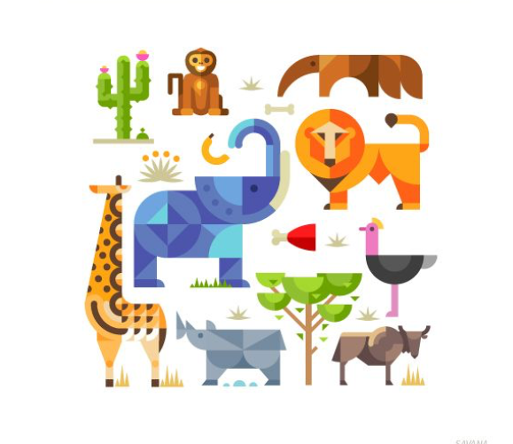
Animal Menagerie Design
Menagerie: a collection of captive animals, frequently exotic, kept for display; or the place where such a collection is kept, a precursor to the modern zoological garden. The term was first used in seventeenth century France in reference to the management of household or domestic stock.

Set up your document as 8 ½ x 8 ½

You will create a specific style for your animals with consistent:
- Economy
- Repetition of shapes/ lines/ textures
- Color scheme (Try using color swatches)
- Originality (nothing directly copied from the internet)
- Arrangement to create a complete SQUARE composition

 | A | B | C | D-F
Overall Effect | The overall design, color, and use of negative space create an interesting and balanced composition. | The overall design, color, and use of negative space create an interesting and mostly balanced composition. | The overall design, color, and use of negative space create a somewhat interesting and balanced composition. | The overall design, color, and use of negative space do not create an interesting and balanced composition.
Animal Style | There is outstanding detailed attention to the consistency of the animals in repetition of shapes/ lines/ textures and in color scheme. | There is mostly detailed attention to the consistency of the animals in repetition of shapes/ lines/ textures and in color scheme. | There is some detailed attention to the consistency of the animals in repetition of shapes/ lines/ textures and in color scheme. | There is little to no detailed attention to the consistency of the animals in repetition of shapes/ lines/ textures and in color scheme.
Illustrator Technique | The pen tool was used properly to create detailed shapes. | The pen tool was mostly used properly to create detailed shapes. | The pen tool was used somewhat properly to create detailed shapes. | The pen tool was not used properly to create detailed shapes.

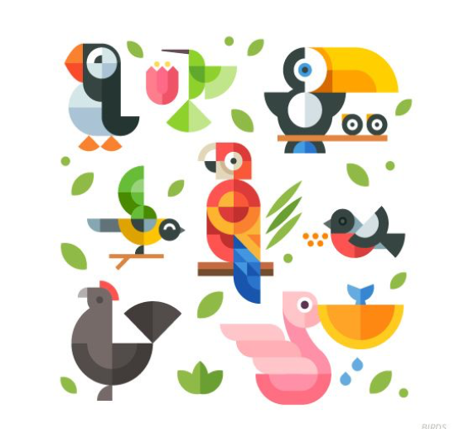
Animal Design Inspiration
