Name: _____________________

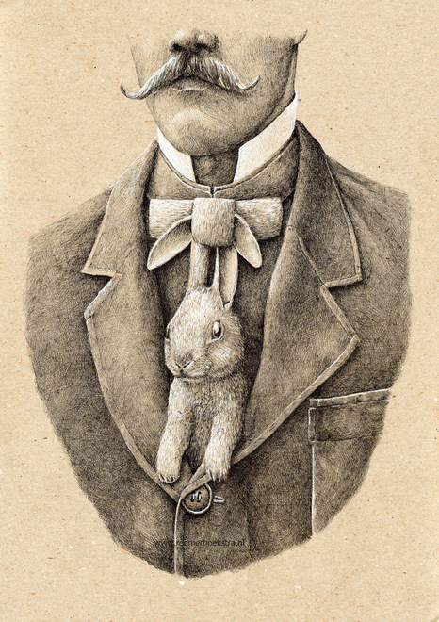
Animal Merge: Redmer Hoekstra

- View the work of Redmer Hoekstra and complete the Analysis in Google Classroom.
- Find/ photo images to be merged. Print, cut and assemble to create image on newsprint
- Transfer onto chipboard using white chalk
- Shade using Black & White Charcoal:
    - Use the chipboard to show through
    - Charcoal Powder
    - Try using hatching and cross hatching to create interest

 | A | B | C | D-F
Originality/ Design/ Composition | There is outstanding and careful attention to merging the animal with an object. The design was created with attention to interest and balance. | There is careful attention to merging the animal with an object. The design was created with attention to interest and balance. | There is attention to merging the animal with an object. The design was created with some attention to interest and balance. | There is little to no attention to merging the animal with an object. The design was created with little to no attention to interest and balance.
Technique | There is outstanding use/ experimentation with Charcoal Powder and/or Crosshatching. | There is outstanding use/ experimentation with Charcoal Powder and/or Crosshatching. | There is outstanding use/ experimentation with Charcoal Powder and/or Crosshatching. | There is outstanding use/ experimentation with Charcoal Powder and/or Crosshatching.
Overall Effect/ Value | There is outstanding attention to the overall balance of values, textures, and design. | There is strong attention to the overall balance of values, textures, and design. | There is some attention to the overall balance of values, textures, and design. | There is little to no attention to the overall balance of values, textures, and design.

