Charcoal Emotional Figure Drawing

Name: ________________________
Study the work of Mark Demsteader
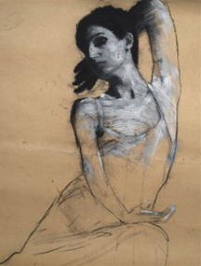
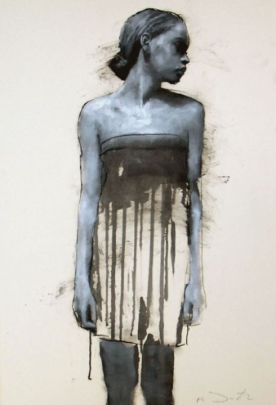
Directions
- Take a photo of your figure.
Things to consider:
- facial expression
- body pose/ attention to negative space created
- clothing choice/ attention to what will become negative space in the body

- Print as a 4 x 6 and grid 4” on 16” x 24” newsprint

- Sketch onto newsprint and decide where negative space/ drip areas will go

- Transfer onto large chipboard

- Apply paint/drips

- Use Black and White Charcoal to render parts of the drawing and transition to lines only

Mark Demsteader was born in 1963 in Manchester where he still lives and works. He studied foundation at Rochdale college and Oldham college, but he is largely self taught having spent many years studying the figure at life drawing classes and developing a unique style through close observation of the human form.
In recent years Mark`s reputation has flourished, such that he has become one of the most popular figurative artists working in Britain today. His powerful depictions of the female form in clean and assured lines of pastel and gouache have sparked a renaissance of interest in traditional life drawing amongst the art collecting fraternity. This immense technical ability is tempered by the natural sensitivity with which he imbues each subject. Although isolated in the picture plane each model seems to live and breathe, their expression and poise conveying a sense of narrative that invites the viewer to ask more questions about them than the artist answers.
Rubric

 | A | B | C | D-F
Asymmetrical Composition | The work is a balanced, asymmetrical piece with attention to placement of negative space. | The work is a balanced, asymmetrical piece with attention to placement of negative space. | The work is a somewhat balanced, asymmetrical piece with some attention to placement of negative space. | The work is not a balanced, asymmetrical piece and has little attention to placement of negative space.
Portrait Value | There is a full range of value and technique in the portrait rendering. | There is a mostly full range of value and technique in the portrait rendering. | There is a range of value and technique in the portrait rendering. | There is little to no range of value and technique in the portrait rendering.
Portrait/ Pose Expression & Overall Effect | The portrait/ pose shows outstanding expression of emotion and works seamlessly with overall space and drips. | The portrait/ pose shows outstanding expression of emotion and works with overall space and drips. | The portrait/ pose shows expression of emotion and works somewhat with overall space and drips. | The portrait/ pose shows little expression of emotion and does not work with overall space and drips.

