Fabric/Clothing “Self Portrait”

In this assignment, you will be creating a fabric/clothing “self portrait” in a circular format. Using your clothing/ fabrics you will create a composition representing yourself. You may also add a small object as an accent.

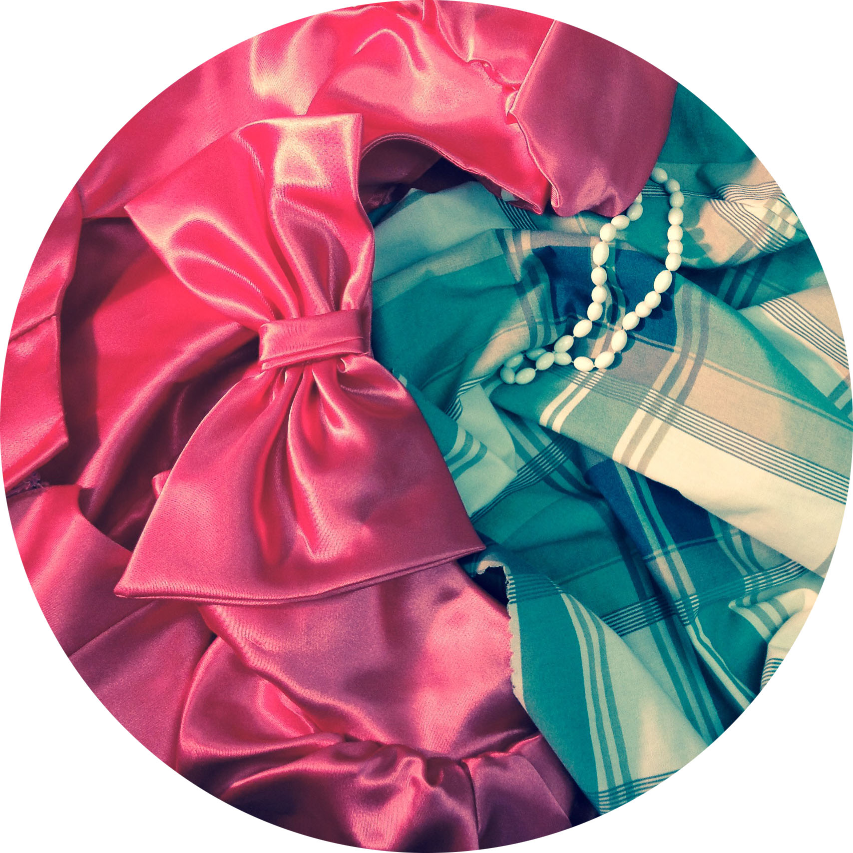
Things to Focus on:
- Texture & Detail: Use interesting fabric texture, patterns, etc. Look for interesting details like stitching, buttons, pockets or zippers
- Composition: Use the circle to create radial/asymmetrical composition with a focal point
- Media Choice: Choose a media that you are comfortable with and that you feel will best accent your fabric choices.

Media Choice:
Black & White Charcoal
or
Colored Pencil

Directions:
- Bring in clothing, fabric, small objects and take a photograph with lamp.
- Choose Media & Edit in PhotoPal and Print
- Use a Circle cropper to crop the image into a circle format
- Choose paper and trace large circle
- Mark halfway points and sketch

Rubric

 | A | B | C | D-F
Composition/ Originality | The composition has a clear focal point and attention to radial/ asymmetrical balance. The subject matter is unique with attention to detail and texture. | The composition has a focal point and attention to radial/ asymmetrical balance. The subject matter is unique with attention to detail and texture. | The composition has somewhat of a clear focal point and some attention to radial/ asymmetrical balance. The subject matter has attention to detail and texture. | The composition has an unclear focal point and little attention to radial/ asymmetrical balance. The subject matter has little attention to detail and texture.
Color Scheme and/or Value | There is a full value range evident with integration of color scheme if applicable. | There is a mostly full value range evident with integration of color scheme if applicable. | There is a value range evident with some integration of color scheme if applicable. | There is little value range evident with little to no integration of color scheme if applicable.
Technical Quality of Media | Excellent skill in application of charcoal or colored pencil is evident. | Skill in application of charcoal or colored pencil is evident. | Some skill in application of charcoal or colored pencil is evident. | Little skill in application of charcoal or colored pencil is evident.

