Name: _______________________

**Coil Pot Final**

Requirements:

* Thumbnails must be completed before beginning
* Finished pot must measure at least 12 inches tall
* Pot must be burnished as it’s drying to create a smooth surface (no tiny bumps or clay balls)
* All outside and inside coils must be blended

|  |  |  |  |  |
| --- | --- | --- | --- | --- |
|  | **A** | **B** | **C** | **D-F** |
| **Construction & Technique** | All attached parts are very secure. There is careful attention to the smoothed surface and shape of the pot. 12 inches tall. | All attached parts are secure. There is mostly careful attention to the smoothed surface and shape of the pot. 12 inches tall. | All attached parts are mostly secure. There is attention to the smoothed surface and shape of the pot. 10-12 inches tall. | Attached parts are not secure. There is little attention to the surface and shape of the pot. Much less than 12 inches tall. |
| **Design** | Well planned, unique shape crafted as an original piece. Interesting to the viewer. | Well planned, shape crafted as an original piece. Interesting to the viewer. | Somewhat well planned, basic shape crafted as an original piece.  Could be slightly misshapen. Interesting to the viewer. | Not well planned, shape is boring, unoriginal or very misshapen. |

**Calendar**

|  |  |  |  |  |
| --- | --- | --- | --- | --- |
| 6  **Tear Down Art**  **Festival** | 7  Introduction to Final Project/ Coil Pot/ Update Online Portfolio | 8  Coil Pot | 9  Coil Pot | 10  Coil Pot  **Vocab 2nd 9 Weeks Test** |
| 13  Coil Pot | 14  Coil Pot | 15  Coil Pot | 16  Coil Pot | 17  Coil Pot |
| 20  Drying  Poster Project | 21  Drying  Poster Project | 22  Drying  Poster Project | 23  Bisque Fire  Poster Project | 24  Bisque Fire  Poster Project |
| 27  **NO SCHOOL** | 28  Glaze Firing | 29  **EXAM PERIOD:**  **LAST GLAZE FIRING** | 30  **45 MINUTES:**  **FINISH ONLINE PORTFOLIO** | 31  30 MINUTES: LOCKER CLEANOUT |

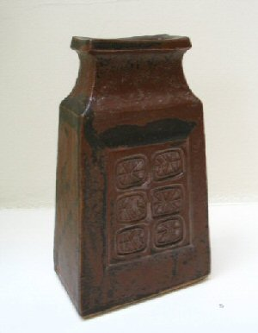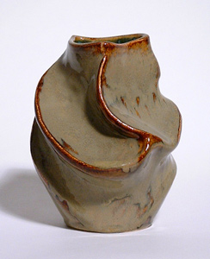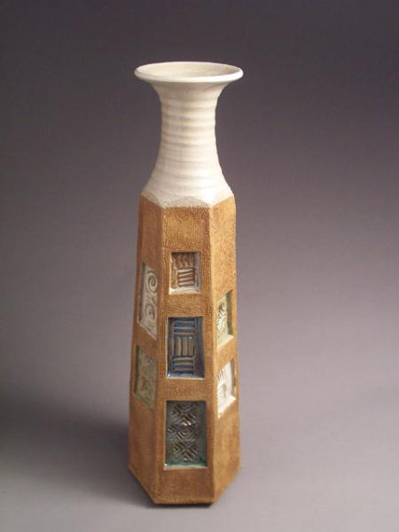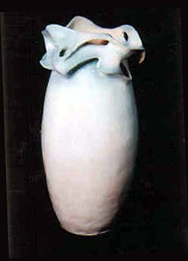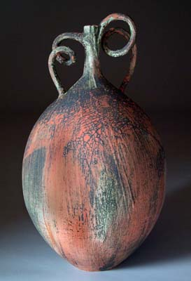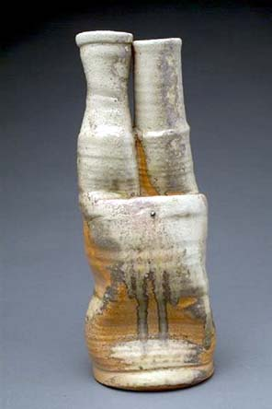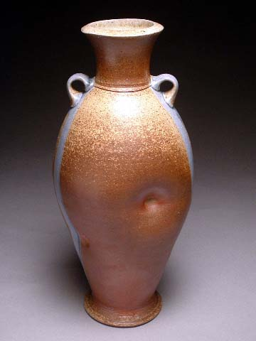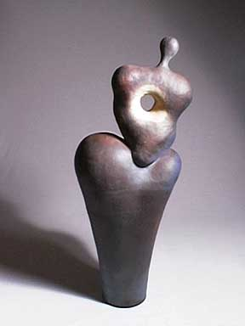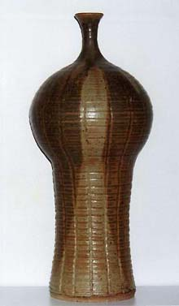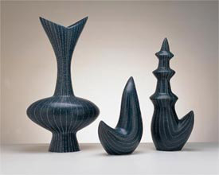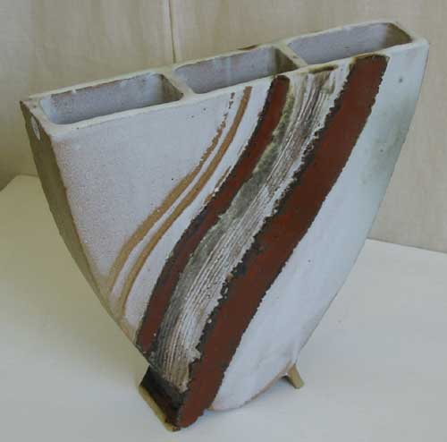[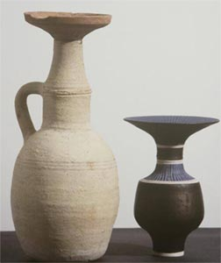](http://www.aber.ac.uk/museum/images/grecorom_lucierie.htm)

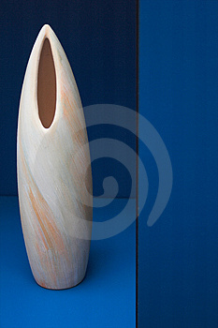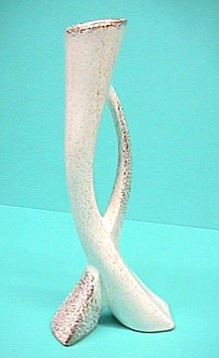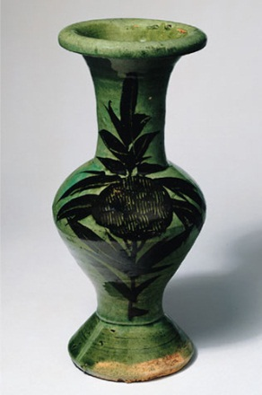[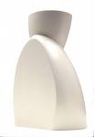](http://images.google.com/imgres?imgurl=http://www.sowdendesign.com/img/lib/hi/2000149.jpg&imgrefurl=http://www.sowdendesign.com/english/portfolio/product/1112/page.html&h=2451&w=1676&sz=1072&hl=en&start=214&tbnid=OAgT-BOzkpqp2M:&tbnh=150&tbnw=103&prev=/images%3Fq%3Dceramic%2Bvase%26start%3D200%26gbv%3D2%26ndsp%3D20%26svnum%3D10%26hl%3Den%26safe%3Dvss%26sa%3DN)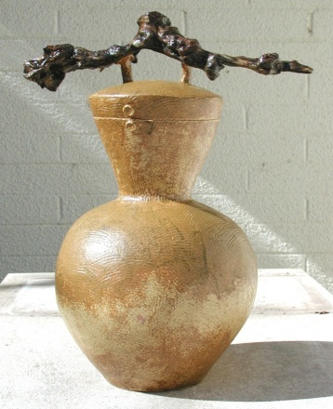

Name: _________________________

**Coil Pot Thumbnails**