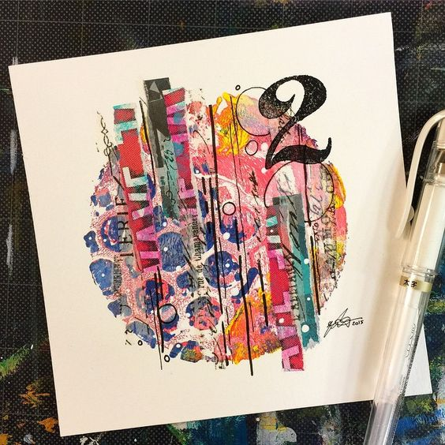
Number/ Letter Collage Watercolor

- Drawing
  - Draw Vertical lines of varying widths through the circle.
  - Draw 5+ circles inside of the circle
  - PRINT Number or Letter—approx. 3” to transfer

- Use Adobe Kuler to make a Triad color scheme that matches the papers and yarn available. PRINT THIS!

- Use these colors to watercolor the strips AND Use these colors to create a plastic wrap wash

- Choose a variety of papers and yarn that fit with your Triad. Glue/ weave these strips vertically.

- Finishing touches may include: Pen & ink, printing, splattering

 | A | B | C | D-F
Watercolor Technique | The amount of water used was varied. Paint was not laid down in an opaque fashion. Washes and other special techniques such as salt, spatter, etc. were utilized to the fullest potential. | The amount of water used was somewhat varied. Some paint was laid down in an opaque fashion. Washes and other special techniques such as salt, spatter, etc. were somewhat utilized to the fullest potential. | The amount of water used was rarely varied. Some paint was laid down in an opaque fashion. Washes and other special techniques such as salt, spatter, etc. were scarcely utilized to the fullest potential. | The amount of water used was very rarely varied. Some paint was laid down in an opaque fashion. Washes and other special techniques such as salt, spatter, etc. were very scarcely utilized to the fullest potential.
Color Scheme | A color scheme was carefully adhered to throughout the piece and was carefully utilized and manipulated by the artist to create areas of interest. | A color scheme was mostly carefully adhered to throughout the piece and was utilized and manipulated by the artist to create areas of interest. | A color scheme was mostly adhered to throughout the piece and was somewhat utilized and manipulated by the artist to create areas of interest. | A color scheme was hardly adhered to throughout the piece and was not carefully utilized and manipulated by the artist to create areas of interest.
Overall Effect/ Textures | The piece exhibits outstanding use of textures and overall pleasing balance and interest. | The piece exhibits good use of textures and overall pleasing balance and interest. | The piece exhibits use of textures and some overall pleasing balance and interest. | The piece exhibits little use of textures and little balance and interest.

