Name: ___________________

**Composition & Focal Point**

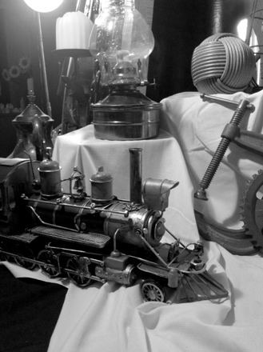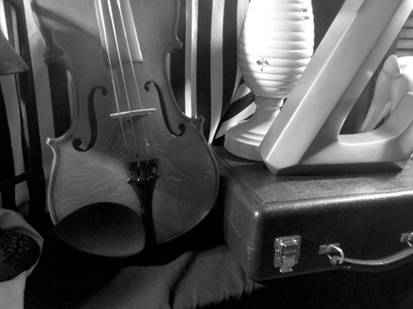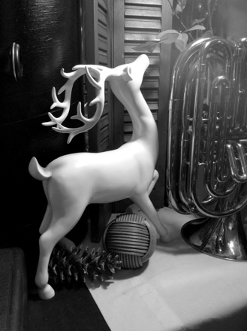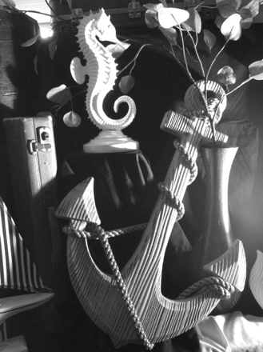

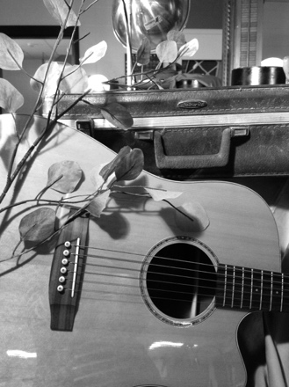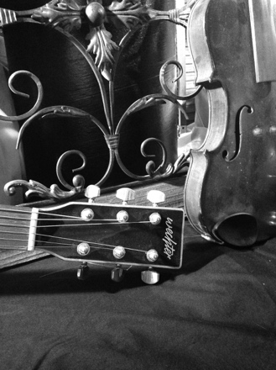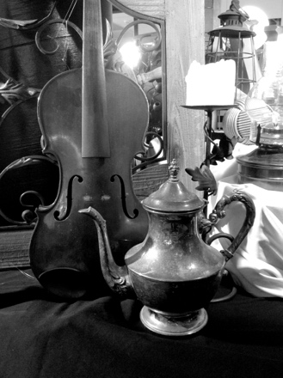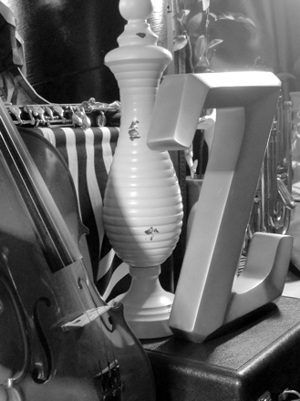

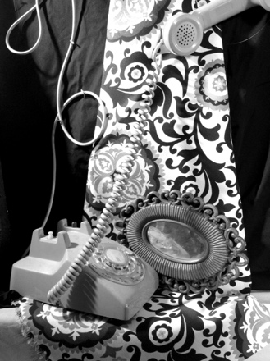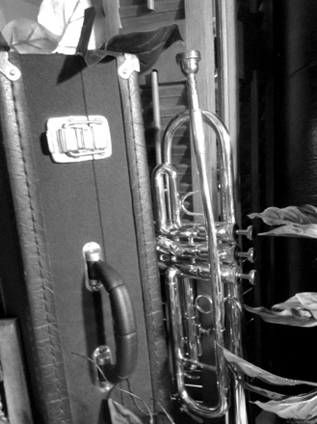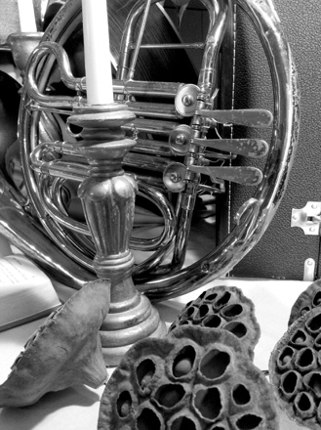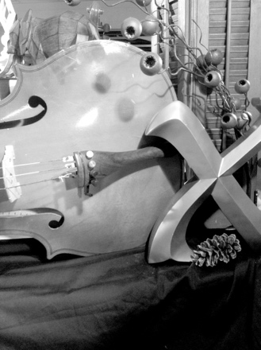

**Ways to Make Your Focal Point Work**

* **Location:** object should be on the Rule of Thirds
* **Contrast:** object is lighter or darker than other parts
* **Isolation:** object is sort of by itself, not much else around it
* **Convergence:** other objects point towards the focal point object
* **Unusual:** object is the only thing like it in the picture (an apple surrounded by oranges)