DISPOSITION
Drawing 1, 2 ,3 --- Painting 1, 2, 3 --- 3-D 1, 2, 3 --- Visual Communications 1, 2, 3
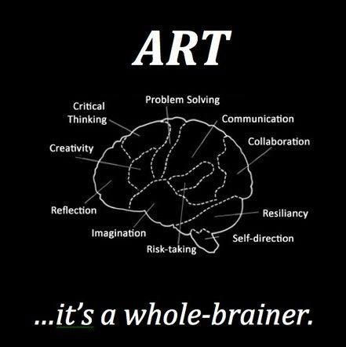
Examples of your possible experiences during this Art course
- learning new techniques, subject matter, or media
- Planning projects/ thumbnails
- Studying a style or piece(s) of art or a video that influences a project
- Conveying content or message through your artwork using technique, pose, media, etc.
- Making a mistake and fixing it/ making it work
- Doing something with your artwork you didn’t expect
- Participating in critiques and comparing your artwork to others
- Learning to analyze a work of art through writing a formal analysis paper
- Listening to a guest speaker, participating in a field trip or an Art Honor activity that influenced your work

The diagram above shows that art engages your whole brain. From the labels on the diagram, choose 3 WORDS you can relate to specific experiences you have had this semester (EXAMPLES IN THE BOX ABOVE).
State each of your 3 chosen words and cite specific examples of how your art experiences in this course support the idea of “art is a whole-brainer”.
Circle, Underline, or Boldface your 3 WORDS.

