Name: __________________________
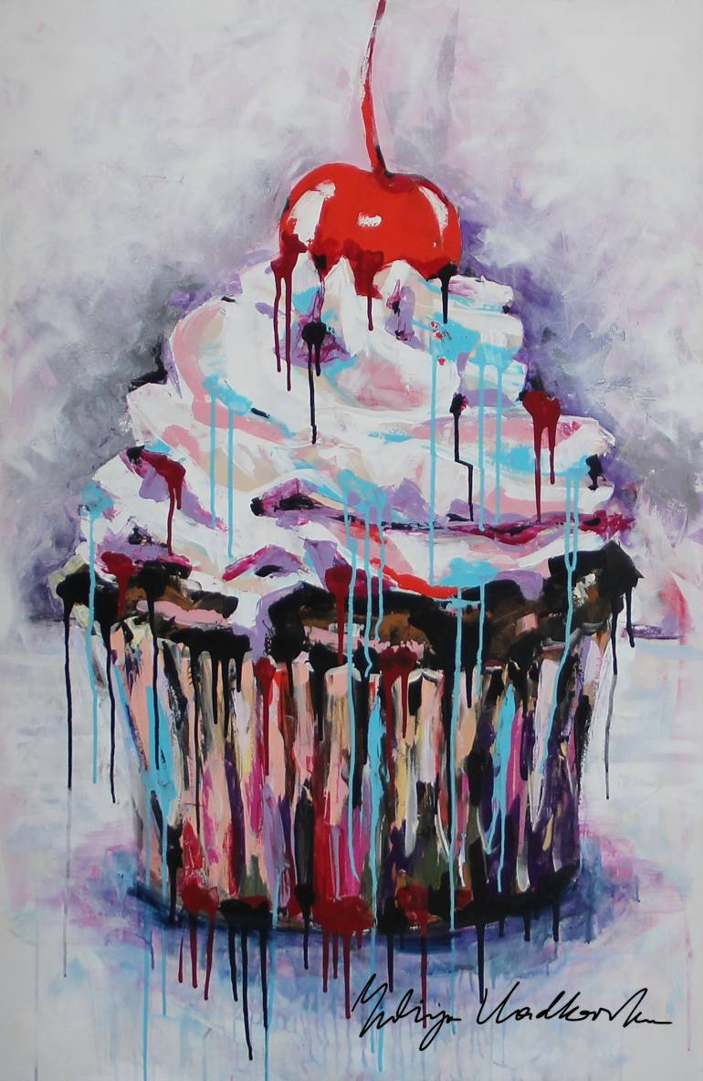
Drip Painting
Painting 2 & 3
Inspiration:
Yuliya Vladkovska

Subject matter:
Choose an object(s) that you feel will give the piece content. Be sure your image/ symbols are clear enough to be understood by the viewer when painted with drips.

Drip Technique:

- Photograph your object(s) in an asymmetrical composition and consider how much space they will take up on the 18 x 24 canvas.

- Use Adobe Color website to choose a Triad or Split Complementary (Compound). You will focus on this combination plus you can use black (you mix) and white.
*****You will need to mix a sample strip of all of your chosen colors

- Paint your canvas with a base coat of one or two of your colors (let dry)

- Add another one of your colors overtop and spray with spray bottle to get drips (let dry)

- Edit your image to have very high contrast and print. Consider negative space or areas that are less busy as the drip technique will fill some space. Print to 3 x 4.

- Use this to sketch it onto your 18 x 24 canvas

- Block in your darkest darks and then choose a few colors from your color combination to lay down as a base on your object. Start showing values with the colors.

- Drip, drip! Build up interest with drips. Keep drips going consistently in one direction unless you have some particular reasoning behind the direction of your drips that adds content.

Drip Painting Rubric

 | A | B | C | D-F
Composition & Proportions | The composition creates outstanding interest with negative space and the proportions of the object are correct. | The composition creates interest with negative space and the proportions of the object are correct. | The composition creates some interest with negative space and the proportions of the object are mostly correct. | The composition creates little interest with negative space and the proportions of the object are not correct.
Use of Color Scheme | The chosen color scheme was adhered and was utilized to create value in the object and overall balance in the piece. | The chosen color scheme was adhered and was mostly utilized to create value in the object and overall balance in the piece. | The chosen color scheme was mostly adhered and was somewhat utilized to create value in the object and some overall balance in the piece. | The chosen color scheme was not adhered and was not utilized to create value in the object and overall balance in the piece.
Subject Matter & Content | The choice of subject matter was thoughtful in content and with the manipulation of the drips. | The choice of subject matter was mostly thoughtful in content and with the manipulation of the drips. | The choice of subject matter was somewhat thoughtful in content and with some manipulation of the drips. | The choice of subject matter was not thoughtful in content and with the manipulation of the drips.
Drip Technique | There is clearly an outstanding buildup of background layers to final drips that create values and form the image of the object. | There is clearly a buildup of background layers to final drips that create values and form the image of the object. | There is some buildup of background layers to final drips that create values and form the image of the object. | There is little buildup of background layers to final drips that create values and form the image of the object.

