Name: __________________________________
Functional Kitchen Ceramics
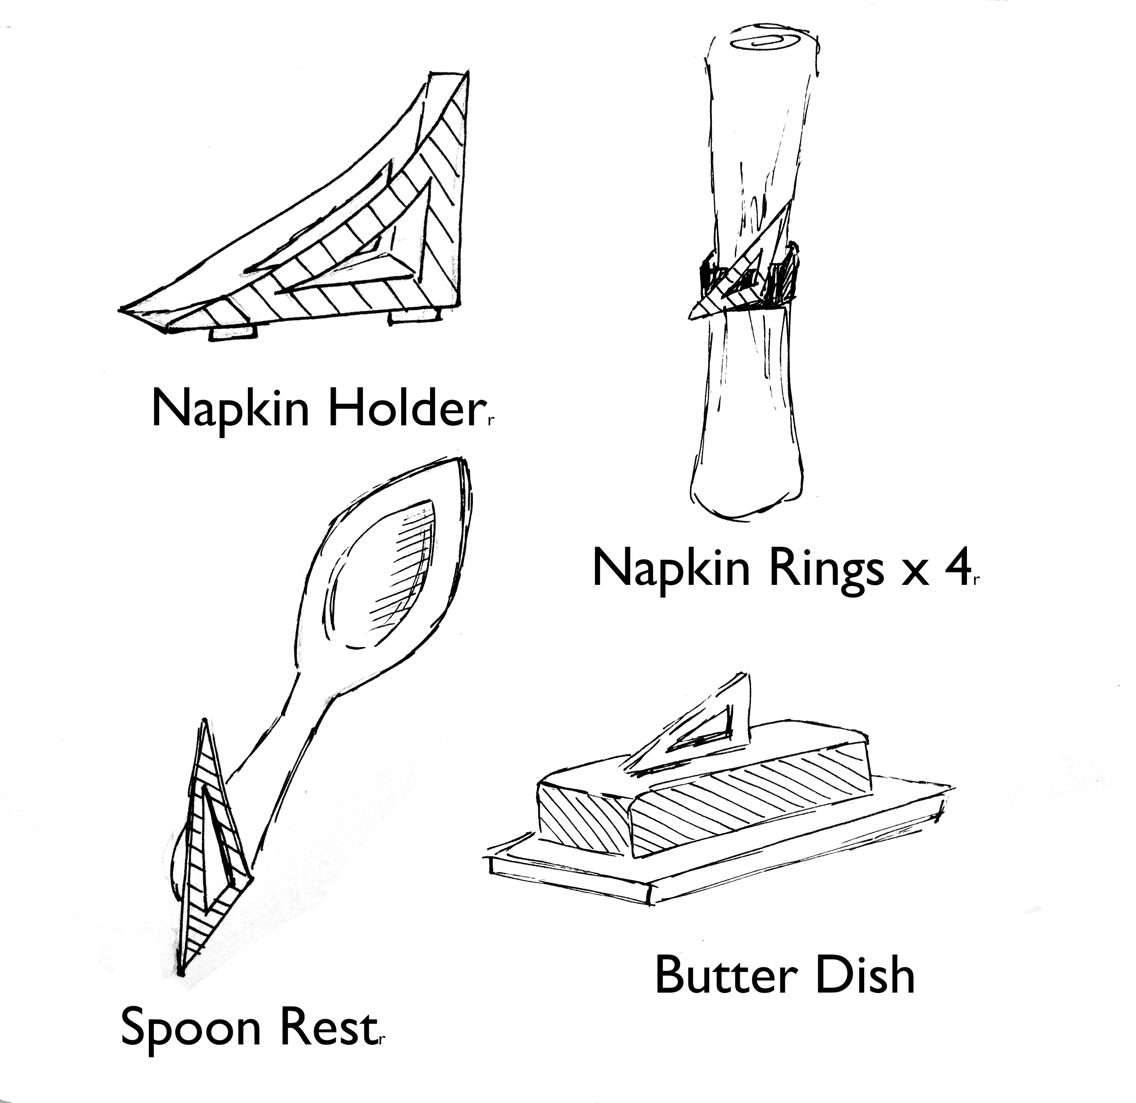
For this project you will create a minimum of 2 of the items in the box at the right.

- Choose two of items and design with a strong motif. Notice the example on the right has a triangle shape with a void that repeats and also has a linear texture that repeats. You need to complete at least two sets of thumbnails… each with a different motif.

- Complete the two chosen items. If time allows, you will be expected to continue making more items as part of the final grade.

Rubric

 | A | B | C | D-F
Construction Technique | Coils or slabs have been uniformly created and connected to achieve a desire shape. | Coils or slabs have mostly been uniformly created and connected to achieve a desire shape. | Coils or slabs have somewhat been uniformly created and connected to achieve a desire shape. | Coils or slabs have not been uniformly created or connected to achieve a desire shape.
Design & Motif | The motif is cleverly integrated into the overall design. The design is consistent and cohesive. | The motif is well integrated into the overall design. The design is consistent and cohesive. | The motif is somewhat integrated into the overall design. The design is somewhat consistent and cohesive. | The motif is not integrated into the overall design. The design is not consistent and cohesive.
Surface Quality | The surface quality has been perfected through shape and through smoothing. | The surface quality has been mostly perfected through shape and through smoothing. | The surface quality has been worked on carefully through shape and through smoothing. | The surface quality has not been worked on carefully through shape and through smoothing.

