Ingredient Poster
- Choose a raw ingredient such as: apple, tomato, carrot, broccoli, peach, lemon, peanut, pineapple

- Research items or food closely associated with the ingredient and different forms of the ingredient. These will need to be clear and recognizable.
Example: Lemon
Lemon slice, lemon wedge, glass of water, lemon juicer, knife, cutting board, zester, straw with stripes, lemon leaf, meringue, lemon & honey, fish or shrimp, liquid measuring cup, teacup/ tea with lemon or teabag
- Search the internet for source imagery to use as reference for building vector graphics of each related item. These will be arranged into the shape of the ingredient.

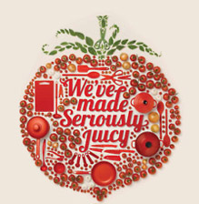
Grading:
Overall Effect: Balance of shapes and aesthetically pleasing formation created with them. Variation in size of objects to create interest.
Illustrator Technique: Quality Illustrator techniques employed with skillful use of pen tool, gradients, text, etc.
Design/ Planning: Effective choice of objects with consideration to design and communication of the final idea.

