Name: __________________
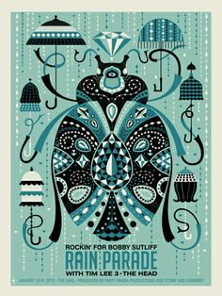
Insect Exhibit Poster

Determine an Audience:

Title of Show/Exhibit:

Name of Museum:

Dates:

TEXT Limit your text. A good rule of thumb for maximum text used is 1/3 and 2/3 for the visuals.
IMAGE Choose an image or two that portrays your message well. Images should be able to capture attention and also relate to the purpose of the poster.
FONT Use no more than two font types and use only three or four font sizes. The importance of the order determines what size to use for text. For example, the headline should have the largest size of text and the benefits should use the smaller size.
COLOR Don't use too many colors. The background should have the soft color and should contrast the text color.
SPACE The layout must have lots of space. By grouping information logically, it controls the eye flow and direct the reader throughout the layout.
DESIGN Design more than one layout. Try different colors, fonts, and sizes and find out what is more appealing.

Insect Exhibit Poster Rubric

 | A | B | C | D-F
Typography | Outstanding use of:  Aligned type, limited fonts, appropriate size and spacing, no font distortion | Effective use of:  Aligned type, limited fonts, appropriate size and spacing, no font distortion | Somewhat effective use of:  Aligned type, limited fonts, appropriate size and spacing, no font distortion | Little to no use of:  Aligned type, limited fonts, appropriate size and spacing, no font distortion
Design & Space | Outstanding use of elements and principles were applied. | Effective use of elements and principles were applied. | Somewhat effective use of elements and principles were applied. | Little to no use of elements and principles were applied.
Image/ Illustrator Technique | The pen tool was used properly to create detailed shapes. | The pen tool was mostly used properly to create detailed shapes. | The pen tool was used somewhat properly to create detailed shapes. | The pen tool was not used properly to create detailed shapes.

