Instrument Typography Poster

Planning
- Choose an instrument and find its shape online. In Google, type “instrument clip art silhouette”.
- Look up the instrument online (Wikipedia, etc) to create a list of related terms.
  - For example, here are some terms related to trumpet: valve, brass, etc. You might also include the letter C because a C trumpet is popular in America.
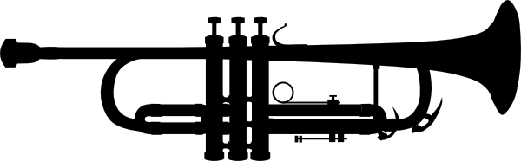
  - After choosing some terms specific to your instrument, you may choose some more general musical terms to bulk up your list.
- Collect at least 15 words to start with (you may need more or less for the actual project)

Project
- Build your silhouette image in Illustrator so that it is a vector graphic.
- Arrange the terms you collected around the instrument. You need to keep these things in mind:
  - Vary the sizes of terms

  - Vary the fonts & boldness of terms (ONLY choose fonts that enhance the overall project)

  - Line up and interlock your terms to create a solid design.

Grading:
Overall Balance/ composition
Illustrator Technique
Typography Technique

Typography References
