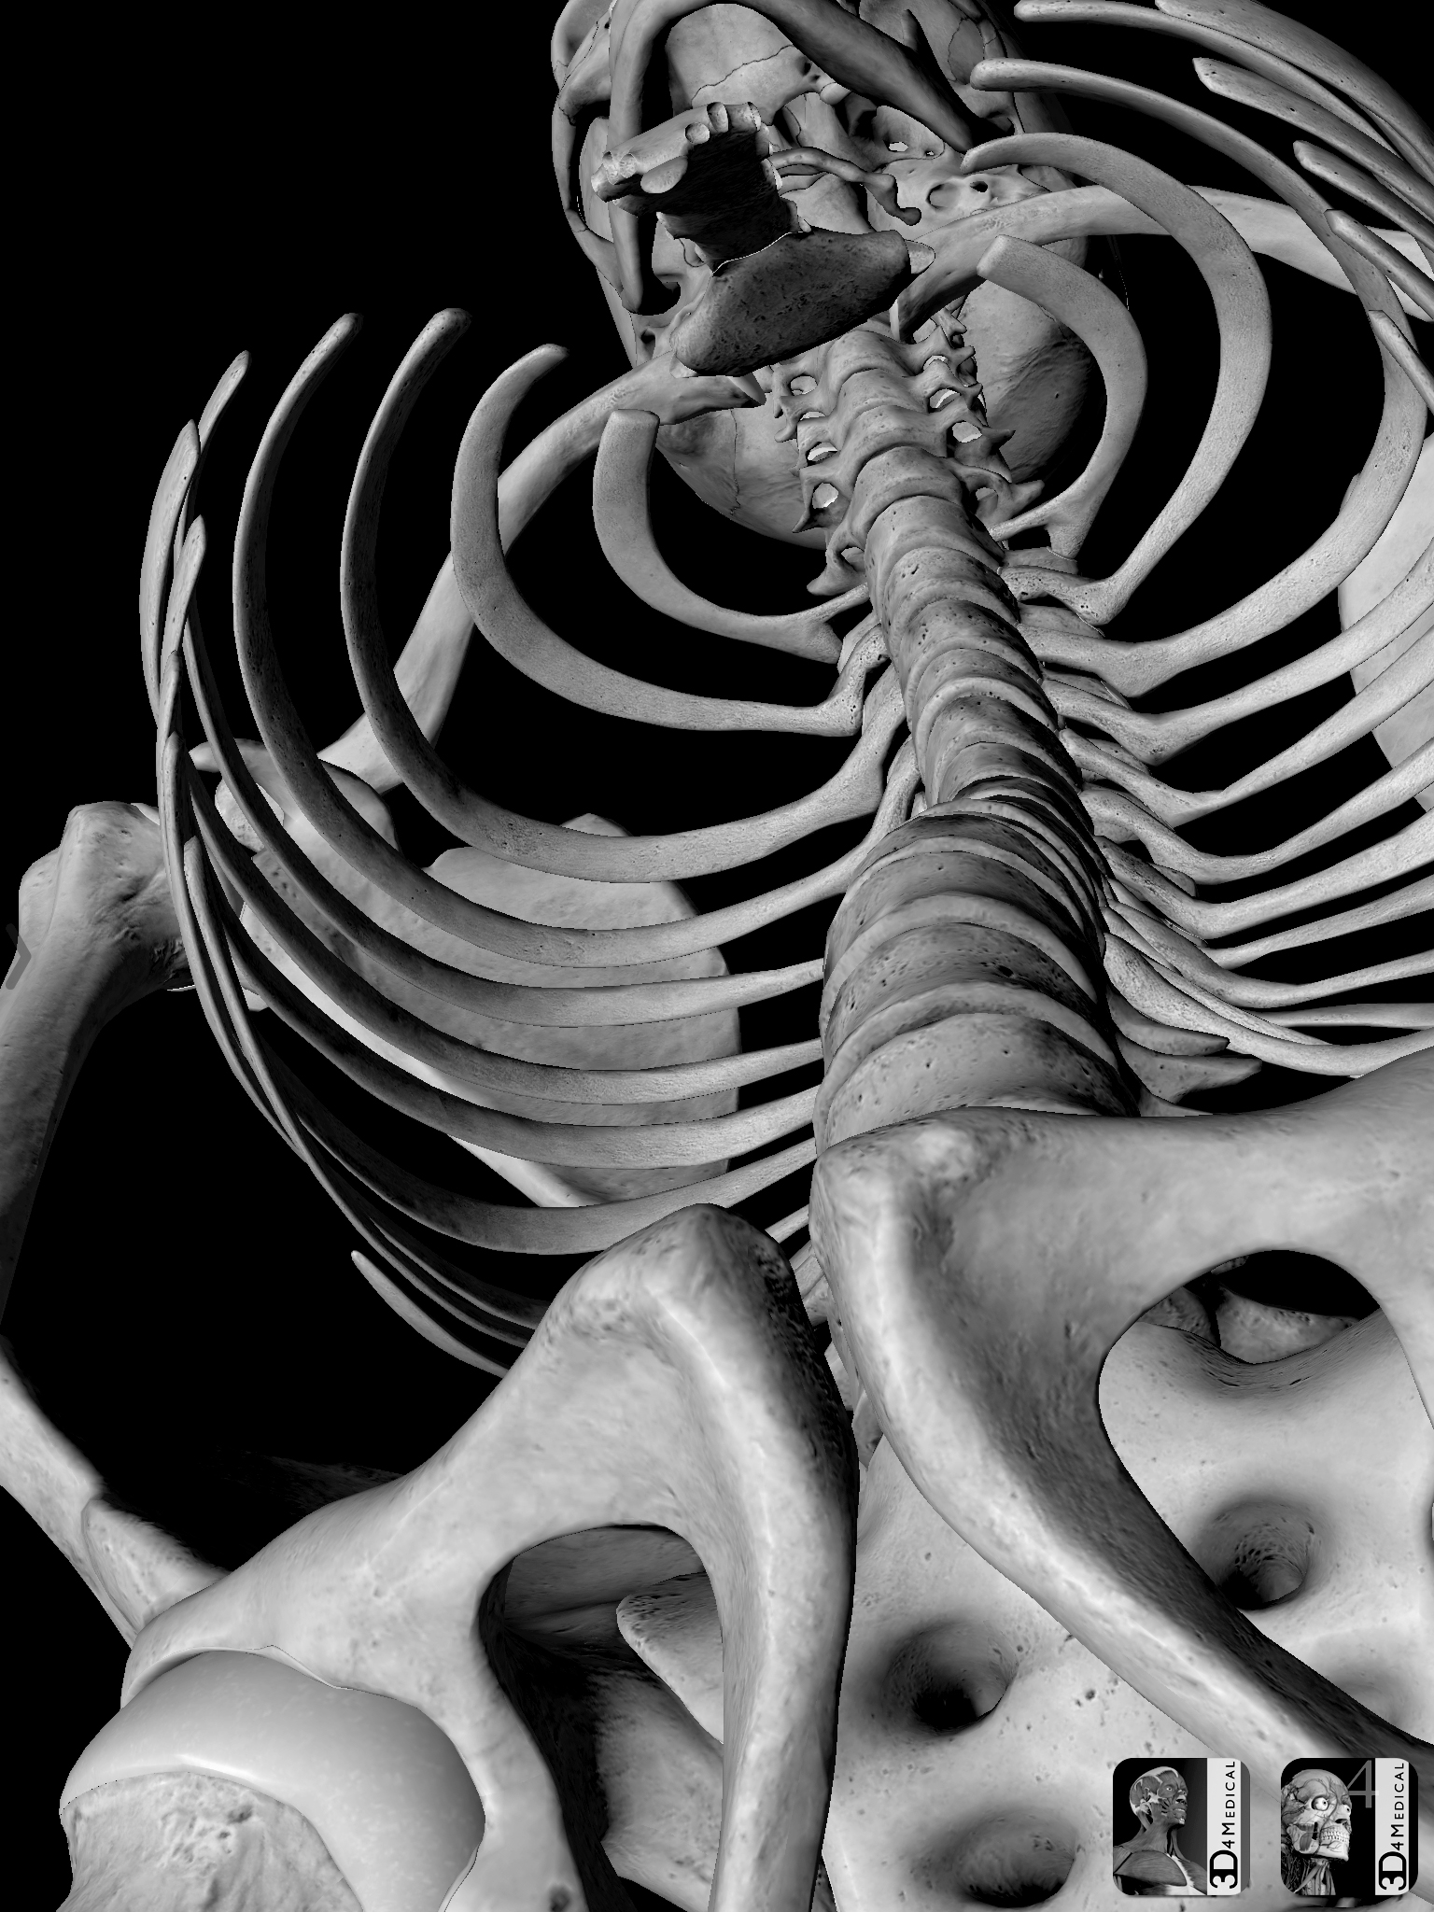
Large Scale Charcoal Skeleton

In this assignment, you will be creating a large scale skeleton in black and white charcoal.
- Use the app 3D 4 Medical to create an interesting composition with a focus on angle and negative spaces.
- Print using Photo Pal on letter size.
- You will grid and sketch the skeleton first.
- Once the drawing is checked thoroughly, you will use acrylic paint to paint your background.
- A careful gray wash should be applied to the bones.
- Use black and white charcoal to render the image.

Rubric
 | A | B | C | D-F
Composition and Focal Point | The piece demonstrates an asymmetrical composition with emphasis on and eye movement to one object or area as the focal point and interesting use of negative space. | The piece mostly demonstrates an asymmetrical composition with emphasis on and eye movement to one object or area as the focal point and interesting use of negative space. | The piece somewhat demonstrates an asymmetrical composition with emphasis on and eye movement to one object or area as the focal point and interesting use of negative space. | The piece does not demonstrate an asymmetrical composition with emphasis on and eye movement to one object or area as the focal point and interesting use of negative space.
Technique & Values | The charcoal is very carefully rendered with a full range of values. | The charcoal is carefully rendered with a full range of values. | The charcoal is somewhat carefully rendered with a good range of values. | The charcoal is not carefully rendered with a full range of values.

