Name: ______________________________

Historical Event Portrait with
Layered Ground
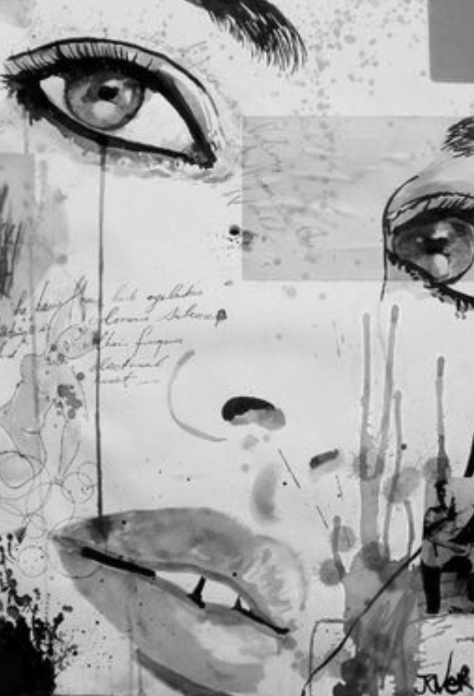
What is a ground?: Short for ‘background’, a ground is the very first layer of paint or other materials applied to an artwork. It is an undercoat, which can either be covered entirely by subsequent media, or left visible in the final work.

In this project, you will be researching a historical event/era as inspiration for a layered ground. You will then prepare a ground and draw a portrait overtop of it that supports an emotion related to the time period.

- Fill out the attached RESEARCH PAGE

- Take a portrait photo. The photo needs to be extreme close up to allow for white empty space in which the ground will show through. The portrait should show an emotion or action related to the chosen historical era/event.
Historical Era or Event Ideas
To browse some ideas:
Go to fairfield.k12.in.us.
Click on World Book at right
Click on Timelines
Examples:
Wright brothers
Woodstock
Victorian Era
Silicon Valley
Thomas Edison
Women’s Suffrage
American Revolution

  - Use PhotoPal to create a high contrast print: 4” X 6”
  - Grid (4”) and sketch on newsprint (16 x 24)

- Prepare your ground.
Create a light gray wash on watercolor paper (dry overnight)/ Watercolor splatters w/ toothbrush

Choose 3-5 of the following to create an interesting ground. Place items strategically to show through in certain areas.
(Transfer and use Sharpie/micron)
- A quote, poem, signature, or other written account
- Years, numbers, mathematical formulas
- Symbols or objects
- Small figures
- patterns

- Transfer portrait to prepared ground. Shade with black & white charcoal.

Historical Event Portrait with Layered Ground RUBRIC

 | A | B | C | D-F
Design | The design is balanced with careful attention to eye movement and placement of object, patterns, textures etc. | The design is mostly balanced with careful attention to eye movement and placement of object, patterns, textures etc. | The design is somewhat balanced with attention to eye movement and placement of object, patterns, textures etc. | The design is not balanced and does not pay attention to eye movement and placement of object, patterns, textures etc.
Technique/ Quality of Ground | The techniques utilized in the ground such as watercolor or pen & ink were done with intense skill and thought to the effects of the overall piece. | The techniques utilized in the ground such as watercolor or pen & ink were done with good skill and thought to the effects of the overall piece. | The techniques utilized in the ground such as watercolor or pen & ink were done with some skill and thought to the effects of the overall piece. | The techniques utilized in the ground such as watercolor or pen & ink were done with little skill and thought to the effects of the overall piece.
Technique/ Quality of Portrait | The technique of the portrait is clearly rendered in black and white charcoal with exceptional attention to working with the ground beneath. | The technique of the portrait is clearly rendered in black and white charcoal with attention to working with the ground beneath. | The technique of the portrait is fairly well rendered in black and white charcoal with some attention to working with the ground beneath. | The technique of the portrait is not well rendered in black and white charcoal and has little attention to working with the ground beneath.
Content/ Idea/ Overall Effect | The piece was designed with outstanding careful choices of imagery that result in a clear emotion or reaction from the viewer. Items create intrigue without “answering all the questions” or being too obvious. | The piece was designed with mostly careful choices of imagery that result in an emotion or reaction from the viewer. Items create intrigue without “answering all the questions” or being too obvious. | The piece was designed with some careful choices of imagery that result in an emotion or reaction from the viewer. | The piece was not designed with careful choices of imagery. There is little to no conveyance of an emotion or reaction from the viewer.

Name: ________________________________
RESEARCH PAGE
Historical Era or Event: ___________________________________________________________________
What Happened? (Brief notes or bullet points or description of the event or era)
Related writing A quote, poem, signature, or other written account, years, numbers, mathematical formulas, etc.

Visual Imagery (BE CAREFUL HERE, THIS IS NOT A HISTORY POSTER, IT IS A WORK OF ART RELATING TO THIS THEME)
- Symbols or objects
- figures (try to take photo yourself if possible)
- patterns (related to the time period or supportive to the emotion you are trying to portray)
You may attach images to this paper, sketch here, or make a list of things to look for

