Name: ___________________
Layered Object Drawing

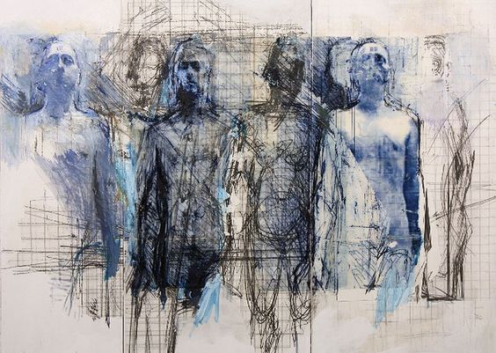

DIRECTIONS
Prep the Images & Ground
- Choose an object and photograph it. Print 8 x 10 (A couple different sizes works well)
- Apply Watercolor Wash/ splatters/ drips to your Ground
- Transfer the object 5-6 times to your Ground

Use each one of these to Render the Object
- Focal Point: Full Color in Colored Pencil

- use acrylic to UNDERPAINT. Re-draw image overtop using 9XXB.

- shade with 1-2 COLORED PENCILS

- shade with CROSSHATCHING using SHARPIE

Other Options to Add
Using an object or fabric to print a texture using paint
Adding a subtle pattern (example uses grid)

Layered Object Drawing Rubric

 | A | B | C | D-F
Composition | There is a clear focal point. One of the images was clearly made to stand out from the rest and create an asymmetrical composition. The other images support the focal point. | There is a focal point. One of the images was clearly made to stand out from the rest and create an asymmetrical composition. The other images support the focal point. | There is somewhat of a focal point. One of the images stand outs from the rest and create an asymmetrical composition. The other images try to support the focal point. | There is not a clear focal point. One of the images was not made to stand out from the rest and create an asymmetrical composition.
Values | Each style shows outstanding attention to values in different techniques. | Each style shows attention to values in different techniques. | Each style shows some attention to values in different techniques. | Each style shows little attention to values in different techniques.
Drawing Qualities | There is outstanding attention to line qualities and varying techniques. | There is attention to line qualities and varying techniques. | There is some attention to line qualities and varying techniques. | There is little attention to line qualities and varying techniques.
Overall Effect | The overall effect is completely balanced between the use of varied techniques, placement of objects, and attention to detail. | The overall effect is balanced between the use of varied techniques, placement of objects, and attention to detail. | The overall effect is somewhat balanced between the use of varied techniques, placement of objects, and attention to detail. | The overall effect is not balanced between the use of varied techniques, placement of objects, and attention to detail.

