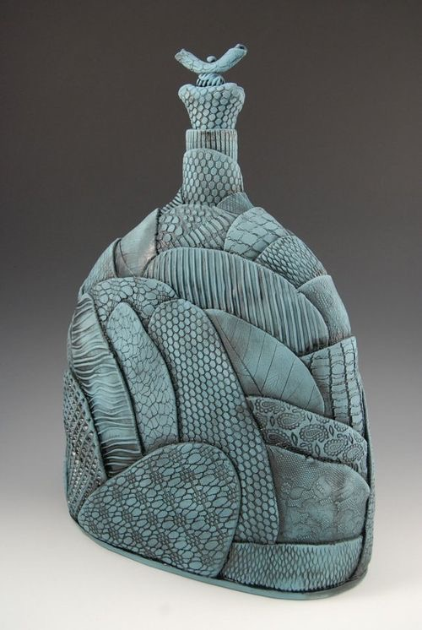

Layered Texture Vessel

Objective:
To create a vessel made of pieces of clay covered in different textures. The final vessel must be 10-12 inches high.

Layered Texture Vessel Rubric

 | A | B | C | D-F
Quality of Pieces/ Construction | Pieces have clean edges and are consistent in design. The pieces have been attached securely. | Pieces have mostly clean edges and are consistent in design. The pieces have been attached securely. | Pieces have mostly clean edges and are mostly consistent in design. The pieces have not all been attached securely. | Pieces have few clean edges and are not consistent in design. The pieces have not been attached securely.
Quality of Textures/ Design | There are at least 2 textures. The textures are carefully imprinted and work the with design of the pieces. | There are at least 2 textures. The textures are mostly carefully imprinted and work the with design of the pieces. | There are at least 2 textures. The textures are somewhat carefully imprinted and mostly work the with design of the pieces. | There may not be at least 2 textures. The textures are not carefully imprinted and do not work the with design of the pieces.
Overall Effect/ Shape of Vessel | The vessel is aesthetically pleasing overall due to repetition of texture and attention to the shape of pieces and to the overall shape of the vessel. | The vessel is mostly aesthetically pleasing overall due to repetition of texture and attention to the shape of pieces and to the overall shape of the vessel. | The vessel is somewhat aesthetically pleasing overall due to repetition of texture and attention to the shape of pieces and to the overall shape of the vessel. | The vessel is not aesthetically pleasing overall due to a lack of repetition of texture and attention to the shape of pieces and to the overall shape of the vessel.

