Line Weight Final

- Prepare your Ground by dyeing your paper with a watercolor wash. You will be dyeing TWO 8” x 10” papers.

- Subject matter: Choose a portrait or object. Be sure your source imagery is original.

- Print image(s) 8” x 10” and transfer to dyed papers.

USE ONE PAPER AS YOUR PRACTICE AND THE OTHER AS YOUR FINAL.

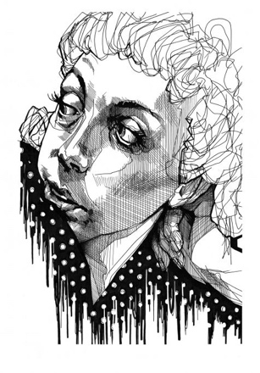
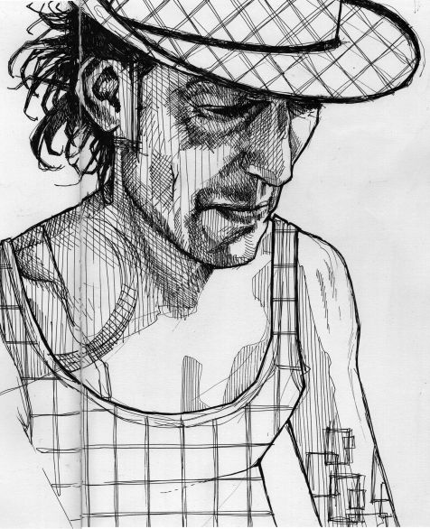
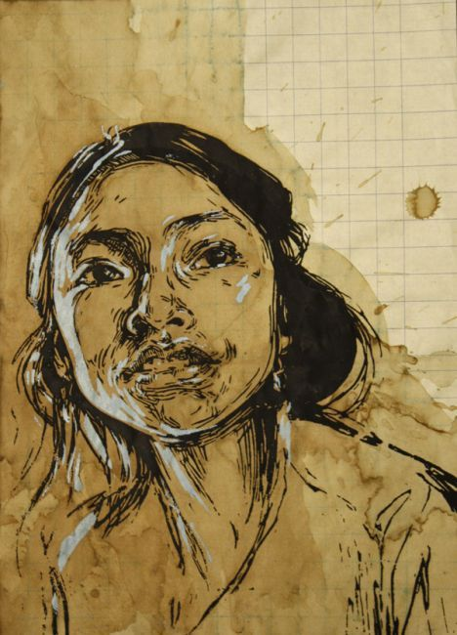
- Ink your images with Sharpie OR Micron.

 | A | B | C | D-F
Line Weight & Style | There is clear, detailed study and execution of line weight variation and style of pen application. | There is detailed study and execution of line weight variation and style of pen application. | There is some study and execution of line weight variation and style of pen application. | There is little to no detailed study and execution of line weight variation and style of pen application.
Value & Negative Space | There is an outstanding full range of value and use of negative space. | There is a full range of value and use of negative space. | There is some range of value and some use of negative space. | There is little to no range of value and use of negative space.
Originality and Overall Stylized Effect | Outstanding attention to the style as well as planned originality of source imagery created an aesthetically pleasing image with content. | Attention to the style as well as planned originality of source imagery created an aesthetically pleasing image with content. | Some attention to the style as well as planned originality of source imagery create a somewhat aesthetically pleasing image with content. | Little attention to the style as well as little planning of originality of source imagery creates non- aesthetically pleasing image with little content.

