Name: __________________________
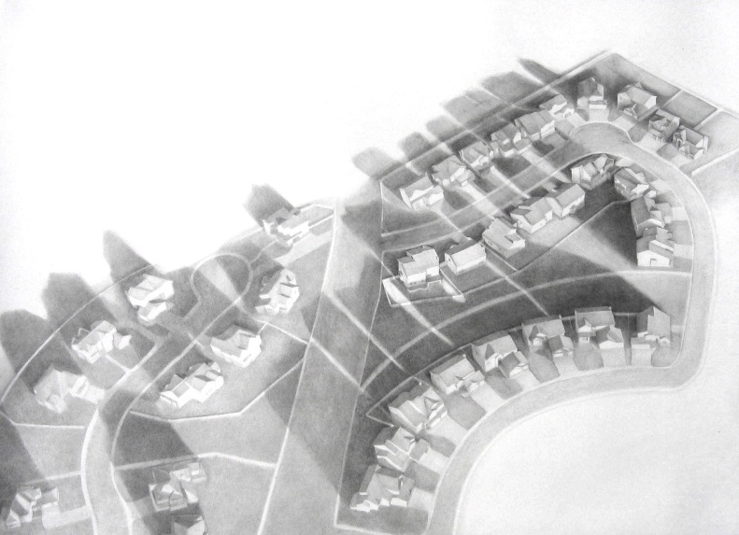
Man vs. Nature Silhouette
View the artwork to the right. How do you think this work could relate to the idea of “man vs. nature”? What ideas do you think the artist is trying to express?

Brainstorming Lists
Write down anything and everything that could be a possible idea for each category.
MAN  (objects and ideas that man controls, invents, uses) | NATURE  (all things natural, environmental, affected or interrupted by things that man does)

Directions

- Take your silhouette photographs. Consider lighting and negative space.
- Print and trace the silhouette.
- Collect additional imagery for your objects representing man vs. nature. Remember NOT TO PLAGERIZE!
- Sketch your ideas within the silhouette shape. Remember to repeat elements to help create balance and harmony. This should be a very thought-through organization of your idea.
- Prepare your ground: You will be using watercolor to create washes and spattering on your background. You need to take into consideration where the face of your portrait will be so that it is not too dark in that area
- Trace your silhouette onto your dry ground.
- Sketch in your objects (these must be finalized before adding Sharpie)
- Sharpie your silhouette/ face
- Shade the objects with black and white charcoal.

Rubric
 | A | B | C | D-F
Originality & Content | The work includes original imagery which is carefully integrated together to express an idea. | The work mostly includes original imagery which is carefully integrated together to express an idea. | The work includes some original imagery which is somewhat integrated together to express an idea. | The work includes little to no original imagery which is not carefully integrated together to express an idea.
Technique | The work includes proper technique: neatly applied pen ad charcoal application. | The work mostly includes proper technique: neatly applied pen ad charcoal application. | The work somewhat includes proper technique: neatly applied pen ad charcoal application. | The work includes little to no proper technique: neatly applied pen ad charcoal application.
Value & Composition | The work includes full range of values and a balanced composition with attention to eye movement. | The work mostly includes full range of values and a balanced composition with attention to eye movement. | The work includes a range of values and a somewhat balanced composition with attention to eye movement. | The work does not include a full range of values and a balanced composition with attention to eye movement.

