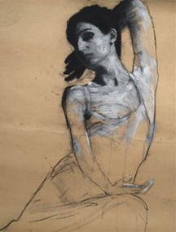Name: ____________________

1. Description of:
   1. Use of line:
   2. Use of drips:
   3. Use of negative space:
   4. Other characteristics
2. Which image do you find the most powerful/striking and why?
3. How would the works be different if they were completely finished?
4. What role does the pose of the figure play in the overall effect of the finished work?
5. What other kinds of poses/ expressions could be interesting with this style applied to them?
6. A quote from Demsteader’s website states: “Although isolated in the picture plane each model seems to live and breathe, their expression and poise conveying a sense of narrative that invites the viewer to ask more questions about them than the artist answers.” In what ways do you think his work supports this statement?

**Mark Demsteader**

