Name: ___________________________
Mixed Media Landscape

Getting Started

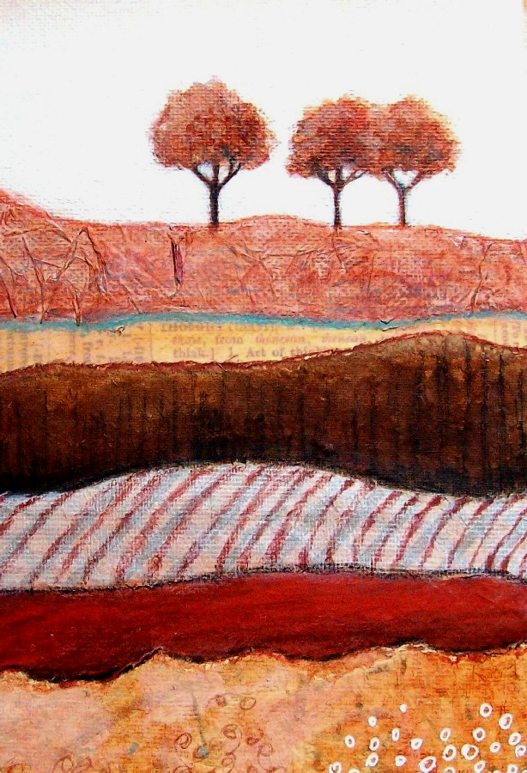
- You will need to find landscape images and choose elements to feature on your horizon line: trees, buildings, etc.

- You will use these images to DESIGN a landscape. The design will feature at least 6 SECTIONS. This is a designed landscape, so it does not have to be completely realistic in atmosphere or depth. Have your thumbnail drawing approved before taking the next step.

Tips to help your design:
- Consider vertical or horizontal format
- Vary the width of your SECTIONS to create interest
- Be sure your horizon line is NOT towards the middle of the paper

Adding Mixed Media & Color to Sections

- Choose Your Analogous Color Scheme: Consider staying away from green, as it is the most expected. You can keep in natural and go with earth tones OR try something more funky like blue-violet, blue, blue-green OR violet, red-violet, red. You DO NOT have to use these colors only… they should be used the most, but other colors can be integrated for accents.
- Sections:
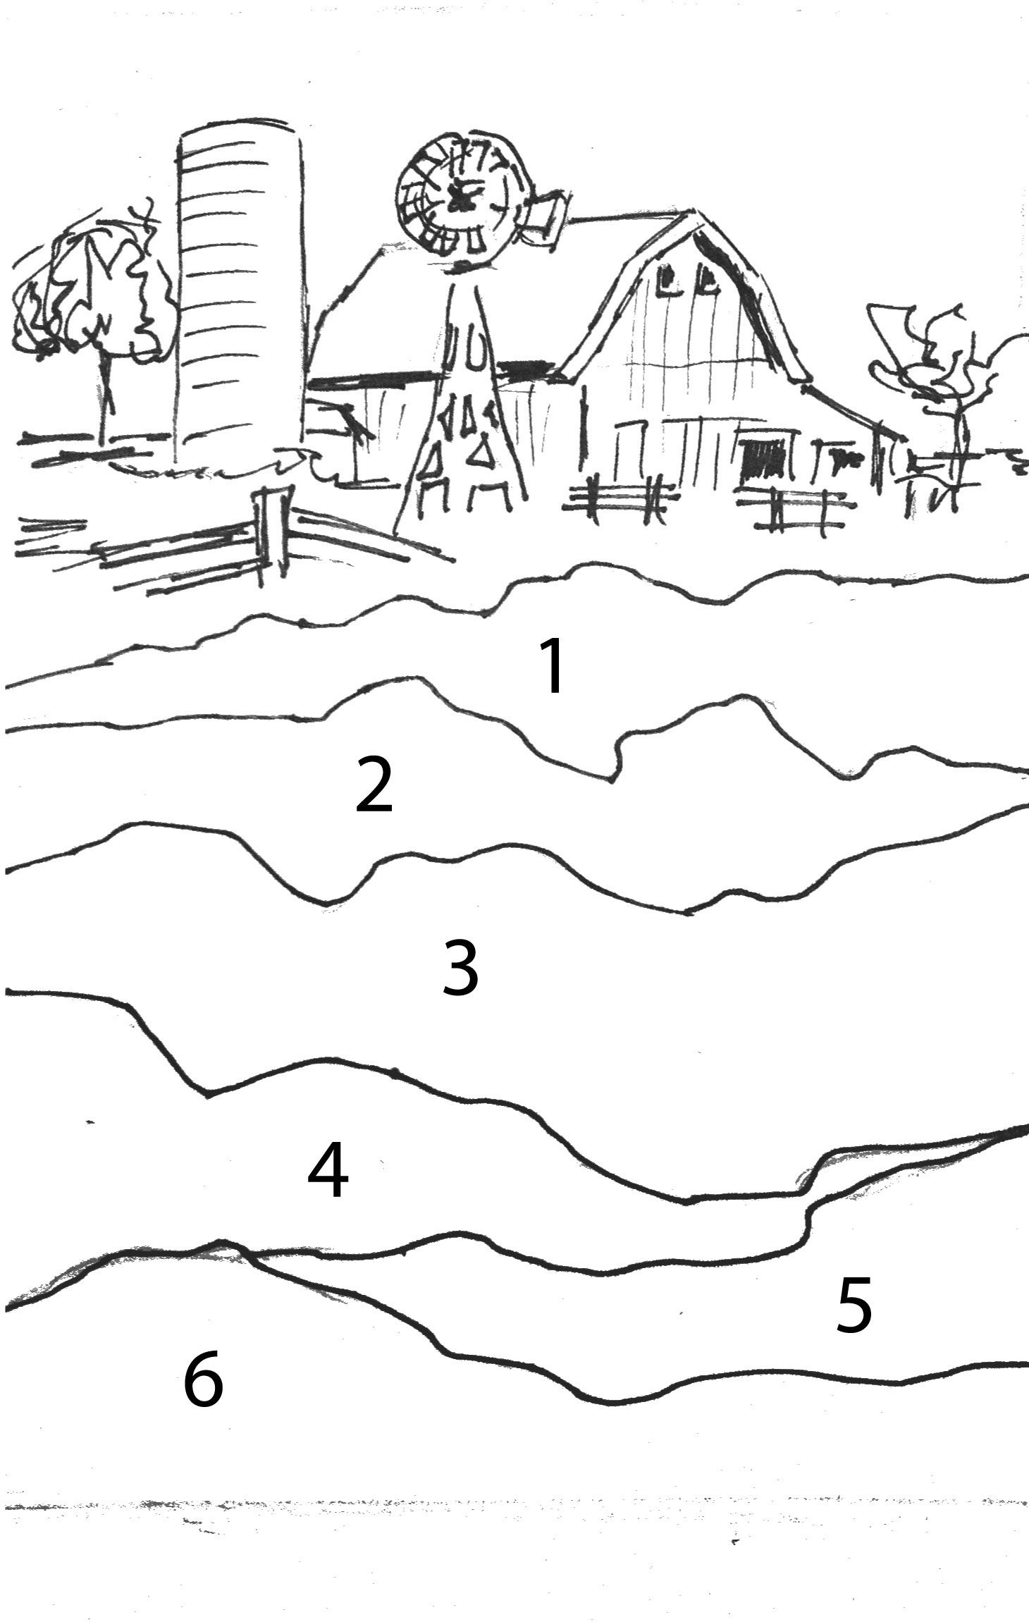
Top Landscape Section
Paint your landscape realistically with attention to your color scheme. Consider letting things get more loose towards the edges.

Bottom Sections (1-6)
Choose from the following:
- Old book pages
- Tissue paper technique
- Corrugated cardboard
- Typography
- Magazine
- Painted pattern (from fabric or scrapbook paper)
- Sticks, yarn, zippers, buttons, ribbon, used postage stamps, rulers, measuring tape, film, keys, etc.
Mixed Media Landscape Rubric

 | A | B | C | D-F
Planning & Composition | There was careful planning in dividing the work and setting up the composition to create asymmetrical balance. | There was mostly careful planning in dividing the work and setting up the composition to create asymmetrical balance. | There was some careful planning in dividing the work and setting up the composition to create asymmetrical balance. | There was not careful planning in dividing the work and setting up the composition to create asymmetrical balance.
Value & Color Scheme | There is strong evidence of a full range of values. The color scheme is carefully integrated throughout the artwork. | There is evidence of a full range of values. The color scheme is carefully integrated throughout the artwork. | There is some evidence of a full range of values. The color scheme is somewhat integrated throughout the artwork. | There is little evidence of a full range of values. The color scheme is not carefully integrated throughout the artwork.
Mixed Media Technique | Each mixed media techniques was carefully implemented with attention to technique and texture. | Each mixed media technique was mostly carefully implemented with attention to technique and texture. | Each mixed media technique was implemented with some attention to technique and texture. | Each mixed media technique was not carefully implemented with attention to technique and texture.
Overall Effect | The overall colors and use of value directs the eye throughout the piece. The color along with subject matter creates a cohesive mood throughout. | The overall colors and use of value directs the eye throughout the piece. The color along with subject matter creates a mostly cohesive mood throughout. | The overall colors and use of value somewhat directs the eye throughout the piece. The color along with subject matter creates some mood throughout. | The overall colors and use of value does not directs the eye throughout the piece. The color along with subject matter does not create a cohesive mood throughout.

