Name: ____________________
Name Logo Redesign
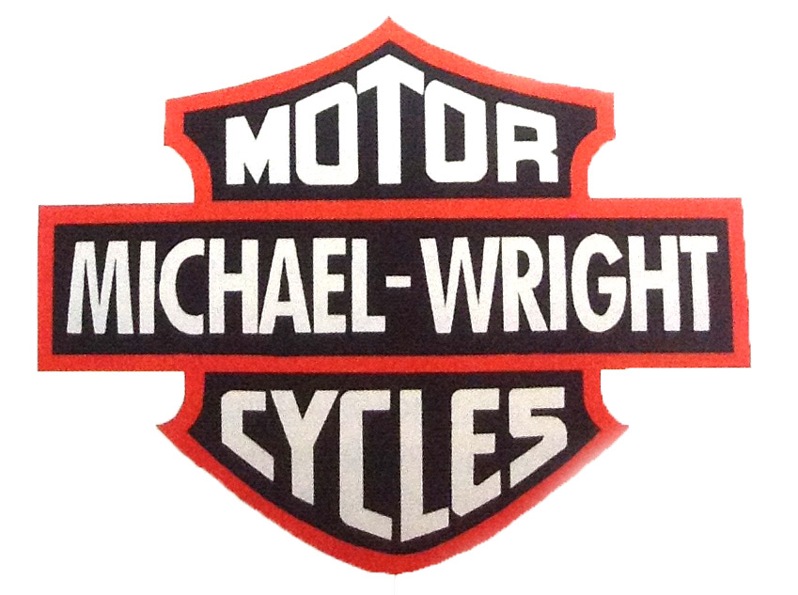
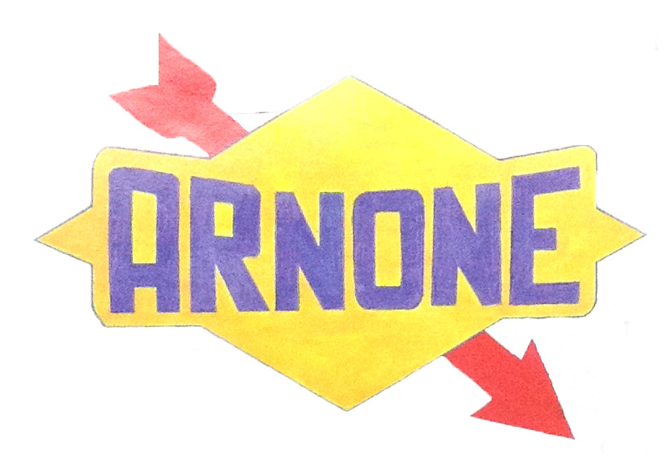

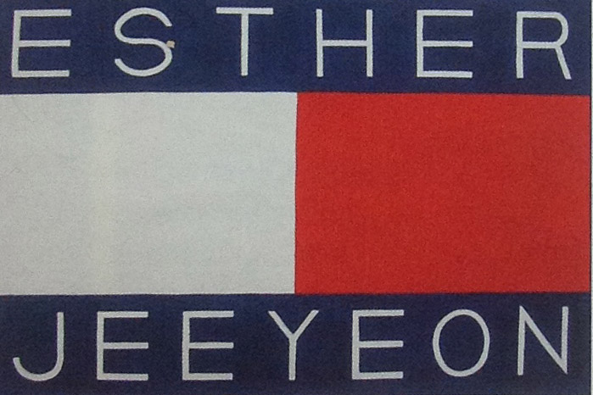

In this assignment, you will be altering a well-known logo to feature your name. You must rebuild all parts in Adobe Illustrator. The challenge is to work with the type to create a convincing blend of your name with the style of the logo.

Rubric

 | A | B | C | D-F
Design/ Text | Text was carefully altered to create a seamless integration of name and logo. | Text was mostly carefully altered to create a seamless integration of name and logo. | Text was somewhat carefully altered to create a seamless integration of name and logo. | Text was not carefully altered to create a seamless integration of name and logo.
Illustrator Technique | A variety of tools were used to create the piece. Graphics are clear and shapes drawn with the pen tool are seamlessly crafted. | A variety of tools were used to create the piece. Graphics are clear and shapes drawn with the pen tool are mostly seamlessly crafted. | Some variety of tools were used to create the piece. Graphics are clear and shapes drawn with the pen tool are decently crafted. | Little variety of tools were used to create the piece. Graphics are not clear and shapes drawn with the pen tool are not well crafted.

