Natural Food with Collage
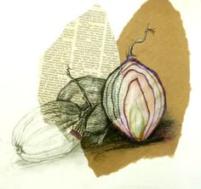
- Bring in 3 of a natural food item such as: onions, peppers, eggs, pears, apples, etc.

- Photograph an arrangement of the three.

- Prepare your ground by gluing the necessary collage elements

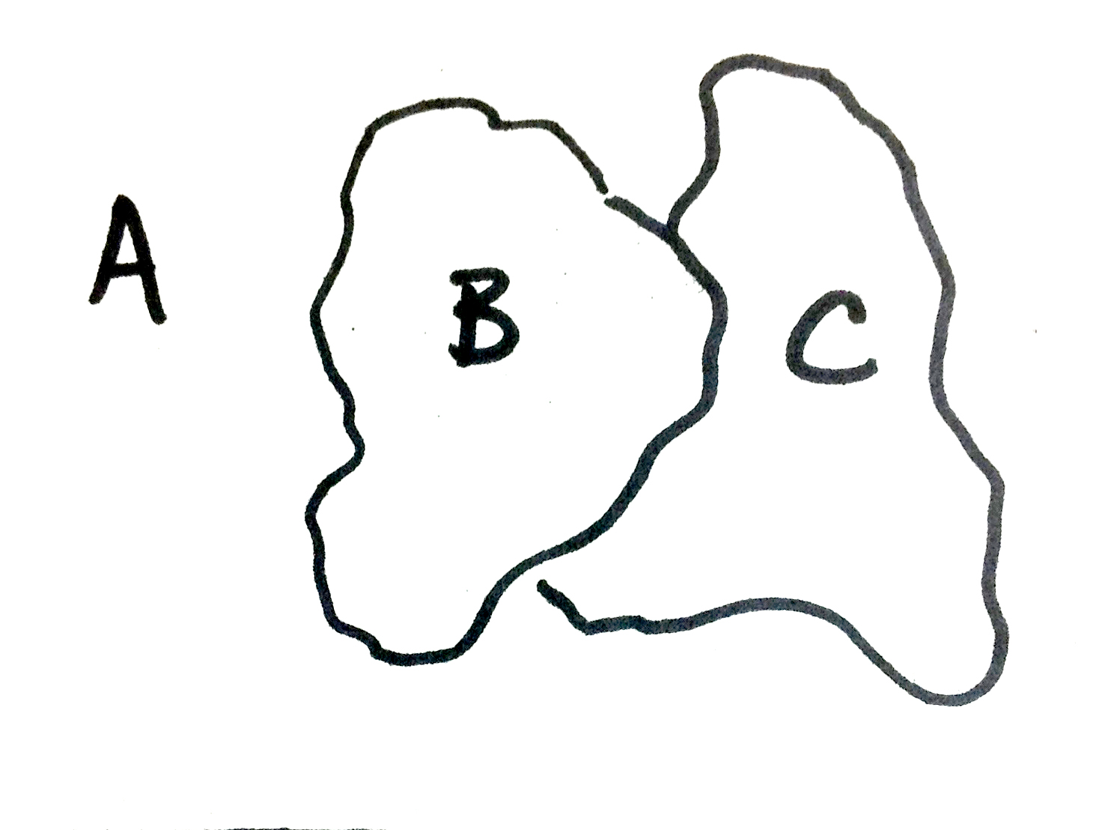

- White with pen & ink
- Newspaper with charcoal
- Color paper with colored pencil

Rubric

 | A | B | C | D-F
Drawing | Drawing was done with correct proportions and sensitivity to line and shape. | Drawing was done with mostly correct proportions and sensitivity to line and shape. | Drawing was done with somewhat correct proportions and sensitivity to line and shape. | Drawing was done with little correct proportions and little sensitivity to line and shape.
Technique | Techniques in Pen, Charcoal, Colored Pencil are done with proper attention to value and rendering style. | Techniques in Pen, Charcoal, Colored Pencil are done with mostly proper attention to value and rendering style. | Techniques in Pen, Charcoal, Colored Pencil are done with somewhat proper attention to value and rendering style. | Techniques in Pen, Charcoal, Colored Pencil are done with little proper attention to value and rendering style.
Overall Balance | There is careful attention to creating an overall balance of color, value, rendering, and composition throughout. | There is mostly careful attention to creating an overall balance of color, value, rendering, and composition throughout. | There is somewhat careful attention to creating an overall balance of color, value, rendering, and composition throughout. | There is little attention to creating an overall balance of color, value, rendering, and composition throughout.
Time | Time was used wisely for planning and rendering throughout the time of the assignment. | Time was mostly used wisely for planning and rendering throughout the time of the assignment. | Time was used somewhat wisely for planning and rendering throughout the time of the assignment. | Time was not used wisely for planning and rendering throughout the time of the assignment.

