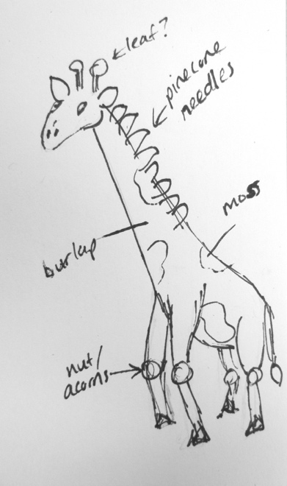
Nature Animal

In this assignment, your focus will be on:

- Building an armature that gives your animal form and character
- Designing with a variety of natural textures to create interest and character in your animal
- Using asymmetrical balance (animal is NOT completely symmetrical)

Directions:

Paper Mache
- Create your animal form using cardboard, wire, newspaper, foil.
- Paper mache over the surface.
- Finish with a layer of paper towel/ paper mache

Adding your Natural Textures
- Sketch your animal on a piece of paper and use the natural textures provided to decorate the surface. Begin by covering most of the surface with burlap or moss. Consider different tones of burlap for different areas of the animal’s body.
- Look for unique ways to utilize special textures, such as the needles of a pinecone for teeth or a long plant strand for a tail.

Rubric

 | A | B | C | D-F
Form Design/ Asymmetrical Balance | The animal form was created with great attention to detail/ accuracy of form and special attention to creating asymmetrical balance. | The animal form was created with attention to detail/ accuracy of form and special attention to creating asymmetrical balance. | The animal form was created with some attention to detail/ accuracy of form and attention to creating asymmetrical balance. | The animal form was created with little attention to detail/ accuracy of form an little to no attention to creating asymmetrical balance.
Natural Elements Design | Extraordinary attention was given to designing with natural elements in aesthetically pleasing and clever ways. | Careful attention was given to designing with natural elements in aesthetically pleasing and clever ways. | Some attention was given to designing with natural elements in aesthetically pleasing and clever ways. | Little to no attention was given to designing with natural elements in aesthetically pleasing and clever ways.
Technique | Paper mache and Natural elements were applied carefully with extreme attention to detail. | Paper mache and Natural elements were applied carefully with attention to detail. | Paper mache and Natural elements were applied mostly carefully with some attention to detail. | Paper mache and Natural elements were applied with little attention to detail.

