Name: _____________________________

Nature Inspired Portrait

Requirements:
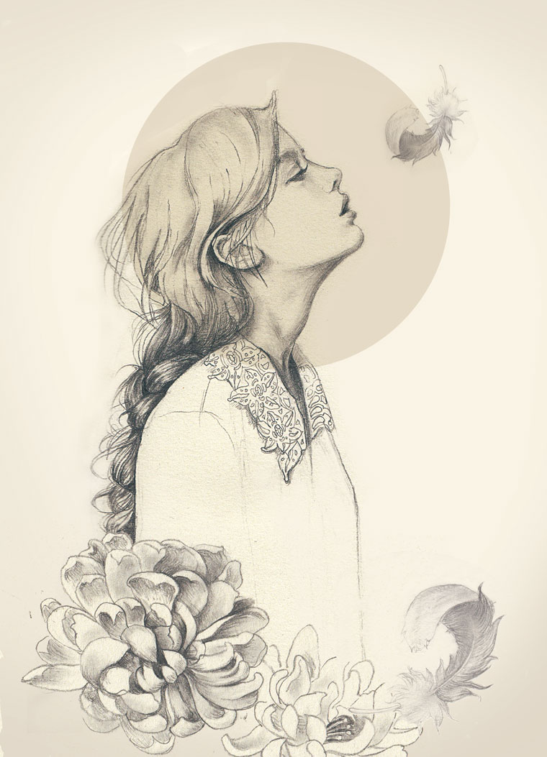
In this assignment, you will create Nature Inspired Portrait that includes the following:

- Well planned asymmetrical composition (with attention to negative space)

- Fully shaded face with possible partially shaded body

- 3 or more natural elements

- At least 1 painted shape that works in harmony with the rest of the piece

Process:

- Create at least 2 rough thumbnail drawings (5 x 7) of your initial ideas while browsing the provided images

- Take portrait photos. Print a 5 x 7 and sketch a more finalized thumbnail with your natural elements. (Could do this by tracing the figure on a new 5 x 7 or sketching overtop of the photo itself)

- Grid your 5 x 7 photo (1”). Grid your newsprint (4”) 20” x 28” Sketch the portrait: fairly detailed but no shading.

- Add natural elements: fairly detailed but no shading.

- When drawing is complete, use graphite to transfer it to the final paper (Fix and finalize the drawing on the final paper, be sure edges are correct)

- Paint the painted shape(s)

- Render drawing with 9XXB pencil.

Rubric

 | A | B | C | D-F
Asymmetrical Composition | The work is a balanced, asymmetrical piece with attention to placement of negative space. There is an outstanding overall effect due to attention to the balance of the painted element, non-rendered areas in balance with areas of full value. | The work is a balanced, asymmetrical piece with attention to placement of negative space. There is a good overall effect due to attention to the balance of the painted element, non-rendered areas in balance with areas of full value. | The work is a somewhat balanced, asymmetrical piece with some attention to placement of negative space. There is some quality overall effect due to attention to the balance of the painted element, non-rendered areas in balance with areas of full value. | The work is not a balanced, asymmetrical piece and has little attention to placement of negative space. There is a poor overall effect due to little attention to the balance of the painted element, non-rendered areas in balance with areas of full value.
Portrait Value | There is a full range of value and technique in the portrait rendering. | There is a mostly full range of value and technique in the portrait rendering. | There is a range of value and technique in the portrait rendering. | There is little to no range of value and technique in the portrait rendering.
Natural Elements Value | There is a full range of value and technique in the natural elements rendering. | There is a mostly full range of value and technique in the natural elements rendering. | There is a range of value and technique in the natural elements rendering. | There is little to no range of value and technique in the natural elements rendering.
Overall Theme/ Content Effect | There is a moving message or powerful synthesis of shapes to create an outstanding work. | There is a message or synthesis of shapes to create a successful work. | There is some message or some synthesis of shapes to create a successful work. | There is little to no message or synthesis of shapes to create a successful work.

