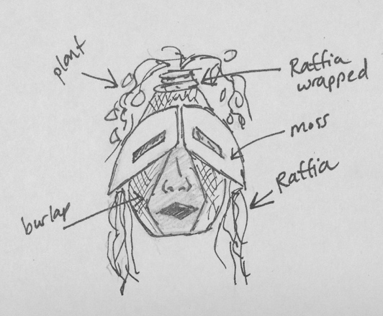
Nature Mask

In this assignment, your focus will be on:

- Using African Mask Forms (shapes) as inspiration for your mask structure
- Designing with Natural Textures to enhance and give character or meaning to the mask
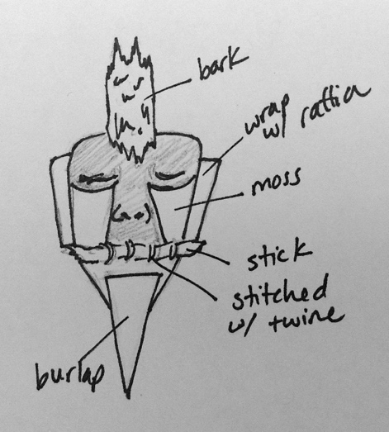
- Using Symmetrical Balance

Directions:

Paper Mache
- Use a mold to create a basic paper mache mask.
- Using Symmetrical balance, design your mask. Once dry, you can cut and reform the mask, add cardboard shapes to imitate African Mask forms. Reassemble and paper mache the mask.
- Add a final coat of paper mache

Adding your Natural Textures
- Sketch your mask on a piece of paper and use the natural textures provided to decorate your mask. Reference back to the African Mask examples.

Rubric

 | A | B | C | D-F
Design & Balance | The design includes symmetrical balance. The arrangement of shapes creates an aesthetically pleasing design that includes attention to space and form. Careful attention was given to African mask influence. | The design includes symmetrical balance. The arrangement of shapes creates an aesthetically pleasing design that includes attention to space and form. Attention was given to African mask influence. | The design includes symmetrical balance. The arrangement of shapes creates a somewhat aesthetically pleasing design that includes attention to space and form. Some attention was given to African mask influence. | The design does not include symmetrical balance. The arrangement of shapes does not create an aesthetically pleasing design that includes attention to space and form. Little attention was given to African mask influence.
Technique | Paper mache and Natural elements were applied carefully with extreme attention to detail. | Paper mache and Natural elements were applied carefully with attention to detail. | Paper mache and Natural elements were applied mostly carefully with some attention to detail. | Paper mache and Natural elements were applied with little attention to detail.

