Name: ___________________

Expression in Colored Pencil, Dry Pastel or Oil Pastel Portrait
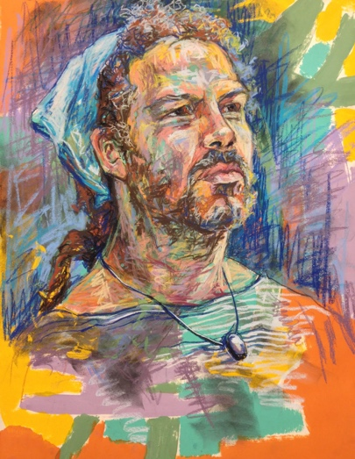
In this assignment, you will be imitating a style of pastel application to enhance your portrait’s expression.

- Choose a style and print 8 x 10. Use a transparency sheet to do the Pastel Analysis

- Photograph your subject. You want to have a mood or feeling present… this is created through position of the subject, technique, and color.

- Practice your technique before you begin. Size of final paper is 15 x 21inches

- Tape your paper to a board. Prop your board on an easel.

 | A | B | C | D-F
Drawing | Correct proportions | Mostly correct proportions | Somewhat correct proportions | Very few correct proportions
Handling of Media & Technique | The media was handled in a professional style with high technical quality. There is strong attention to detail and values. | The media was handled in a professional style with high technical quality. There is attention to detail and values. | The media was handled in a professional style with high technical quality. There is some attention to detail and values. | The media was handled in a professional style with high technical quality. There is little attention to detail and values.
Color | A set color scheme or value scale was implemented to create a strong unity of the piece. | A set color scheme or value scale was implemented to create unity of the piece. | A set color scheme or value scale was implemented to create some unity of the piece. | A set color scheme or value scale was not implemented to create a strong unity of the piece.

Name: ___________________

Expression in Colored Pencil, Dry Pastel or Oil Pastel Portrait
In this assignment, you will be imitating a style of pastel application to enhance your portrait’s expression.

- Choose a style and print 8 x 10. Use a transparency sheet to do the Pastel Analysis

- Photograph your subject. You want to have a mood or feeling present… this is created through position of the subject, technique, and color.

- Practice your technique before you begin. Size of final paper is 15 x 21inches

- Tape your paper to a board. Prop your board on an easel.

 | A | B | C | D-F
Drawing | Correct proportions | Mostly correct proportions | Somewhat correct proportions | Very few correct proportions
Handling of Media & Technique | The media was handled in a professional style with high technical quality. There is strong attention to detail and values. | The media was handled in a professional style with high technical quality. There is attention to detail and values. | The media was handled in a professional style with high technical quality. There is some attention to detail and values. | The media was handled in a professional style with high technical quality. There is little attention to detail and values.
Color | A set color scheme or value scale was implemented to create a strong unity of the piece. | A set color scheme or value scale was implemented to create unity of the piece. | A set color scheme or value scale was implemented to create some unity of the piece. | A set color scheme or value scale was not implemented to create a strong unity of the piece.

