Name: _____________________
FINAL: Prepared Ground

Directions
Preparing your Ground
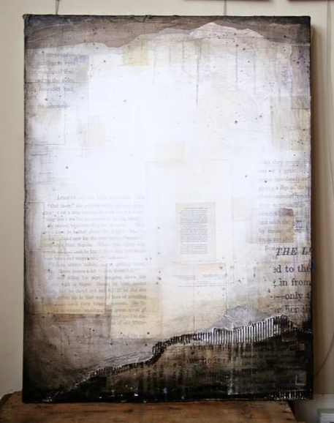
- Mod Podge torn newspaper and book pages to your 18 x 24 canvas
- Mod Podge cardboard strips with corrugation and torn edge (option: top and/or bottom)
- Paint black acrylic on top and bottom and fade onto sides:
  - Use DRY PAPER TOWEL to blend
  - Use WET PAPER TOWEL to blend while partially dry
- When all is dry, paint spiral of white spray paint from center to get soft edges on circle. Touch up with white paint if needed.

Choose from Subject Matter Options
- Landscape
- Plants
- Figures
- Industrial

Sketch and Paint in Black and White*
*USE THE NEGATIVE SPACE TO YOUR ADVANTAGE—
  - where will the image be opaque/ where will the image be transparent?
  - Pay attention to the size of the image—there should be resting space to enjoy the texures of the prepared ground.

Rubric

 | A | B | C | D-F
Prepared Ground | The ground was exceptionally prepared following the steps and was handled with care. | The ground was correctly prepared following the steps and was handled with care. | The ground was mostly correctly prepared following the steps and was handled with some care. | The ground was not well prepared following the steps and was not handled with care.
Value | There is a full range of values in the image. | There is a mostly full range of values in the image. | There is some range of values in the image. | There is little range of values in the image.
Painting Technique | There is exceptional attention to painting technique through use or brushstroke, drip or texture. | There is great attention to painting technique through use or brushstroke, drip or texture. | There is some attention to painting technique through use or brushstroke, drip or texture. | There is little to no attention to painting technique through use or brushstroke, drip or texture.
Overall Effect/ Use of negative space | Exceptional care was given to choice of subject matter and creation of the prepared ground to work together as a whole and use the negative space to an advantage. | Great care was given to choice of subject matter and creation of the prepared ground to work together as a whole and use the negative space to an advantage. | Some care was given to choice of subject matter and creation of the prepared ground to work together as a whole and somewhat use the negative space to an advantage. | Little to no care was given to choice of subject matter and creation of the prepared ground to work together as a whole and there is no use the negative space to an advantage.

