Name: __________________________
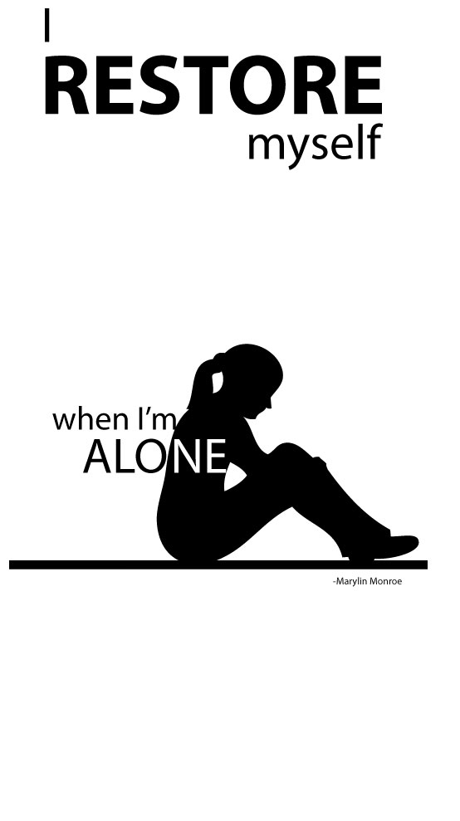
Quote & Silhouette

- Internet research: Find a high resolution silhouette figure & a quote to go with it

- Set up your workspace in Illustrator. Try 12 x 24 inches.. this is the general size but if different proportions are needed that’s fine. You might also want it horizontal or vertical.

- Use Object: Live Trace: Tracing Options…. Check preview and make sure it’s set to Black and White. This is turning the image from a Raster graphic to a Vector graphic. You must have a high resolution image for this to work well.

- Type your quote… use the font to enhance the expression behind your quote and silhouette. Consider the font’s:

    - Placement (use of negative space)
    - Size
    - Font style
    - Alignment with other text
    - Positive/ Negative effects
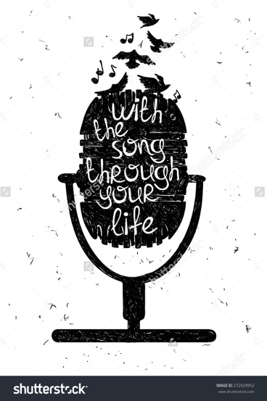
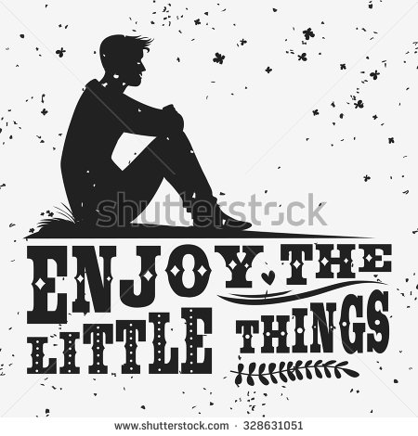
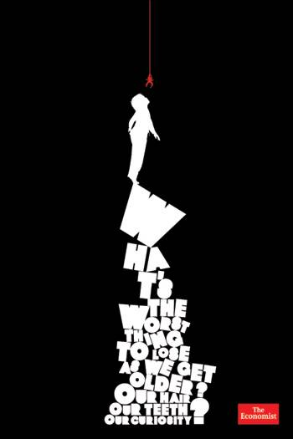

Name: __________________________

Quote & Silhouette RUBRIC

Design | Composition was clearly thought out. There is use of the silhouette as a focal point and support from negative space and attention to placement of the quote. | Composition was mostly clearly thought out. There is use of the silhouette as a focal point and support from negative space and attention to placement of the quote | Composition was somewhat thought out. There is use of the silhouette as a focal point and some support from negative space and attention to placement of the quote | Composition was not clearly thought out. There is little use of the silhouette as a focal point and little support from negative space and attention to placement of the quote
Technical Quality | Illustrator tools were used thoughtfully to create the composition. Only appropriate tools were used. Details are assessed. | Illustrator tools were mostly used thoughtfully to create the composition. Only appropriate tools were used. Details are assessed. | Illustrator tools were somewhat used thoughtfully to create the composition. Only appropriate tools were used. Details are assessed. | Illustrator tools were not used thoughtfully to create the composition. Only appropriate tools were used. Details are assessed.
Quote Expression | The placement, size, spacing, etc. of the quote paired with the silhouette emphasis the idea behind the quote and clearly help express it. | The placement, size, spacing, etc. of the quote paired with the silhouette mostly emphasis the idea behind the quote and help express it. | The placement, size, spacing, etc. of the quote paired with the silhouette somewhat emphasis the idea behind the quote and help express it. | The placement, size, spacing, etc. of the quote paired with the silhouette does not emphasis the idea behind the quote and does not help express it.

