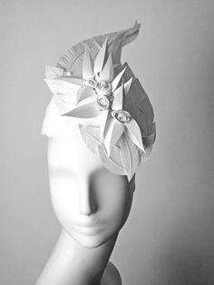
Sculptural Hat

Your HAT will include:
- An original, artistic design (no baseball caps)
- Asymmetrical balance with a focal point
- Shapes that repeat, overlap, and vary in size
- Creative textures
- Space & Form:
    - 3D folds
    - Voids
    - Sculpture in the Round

Materials:
White paper (visible)
Cardboard, paper mache, posterboard (structure underneath where necessary)

Rubric
 | A | B | C | D-F
Design & Balance | The design includes asymmetrical balance and a focal point. Arrangement of shapes creates an aesthetically pleasing design that includes attention to space and form. | The design includes asymmetrical balance and a focal point. Arrangement of shapes creates a mostly aesthetically pleasing design that includes attention to space and form. | The design includes asymmetrical balance and a focal point. Arrangement of shapes creates a somewhat aesthetically pleasing design that includes attention to space and form. | The design includes asymmetrical balance and a focal point. Arrangement of shapes does not create an aesthetically pleasing design that includes attention to space and form.
Technique | The design includes all interesting and clean folds, clean edges. No viewable tape, glue or other adhesives. | The design mostly includes interesting and clean folds, clean edges. No viewable tape, glue or other adhesives. | The design includes some interesting and clean folds, clean edges. No viewable tape, glue or other adhesives. | The design includes little to no interesting and clean folds, clean edges. No viewable tape, glue or other adhesives.
Texture & Form | There is detailed thought and creativity in the textures and form in the piece. | There is mostly detailed thought and creativity in the textures and form in the piece. | There is somewhat detailed thought and creativity in the textures and form in the piece. | There is little detailed thought and creativity in the textures and form in the piece.

Sculptural Hat Thumbnails

