Name:_________________
Self Portrait CHECKLIST: Drawing 1
Practice Sheet & Portrait Sheet

 |  | Practice & Portrait Progress | Checklist
Day 1 | Toolbox Video  Facial Proportion Video | 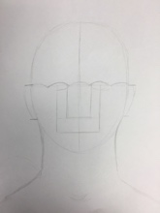
Day 2 | Eyes Part 1 Video  Eyes Part 2 Video | 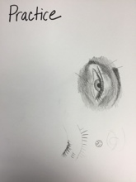
Day 3 | Finish Eyes | 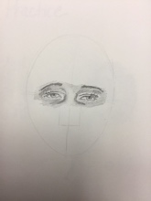
Day 4 | Nose Video | 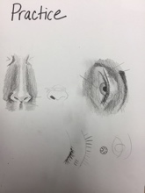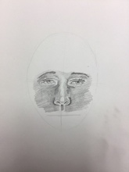
Day 5 | Mouth Video | 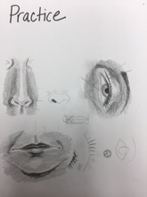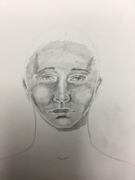
Day 6 | Neck & Shoulder Video | 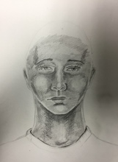
Day 7 | Hair Video | 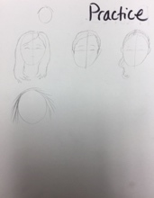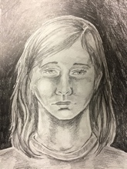
Day 8-10 | Finishing Portrait

http://artsparksfairfield.weebly.com/drawing-1-new.html

