Name: ________________________

Slab Clay Lantern

- Roll slabs, dry to almost leatherhard and use metal cutouts.
- Assemble slabs into 3-D form
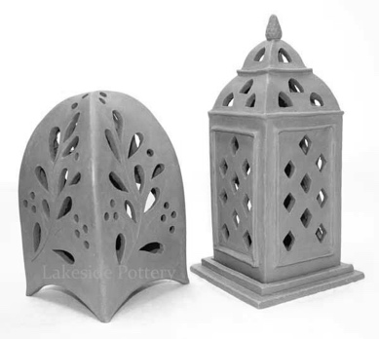
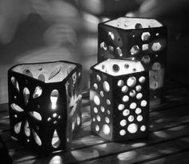
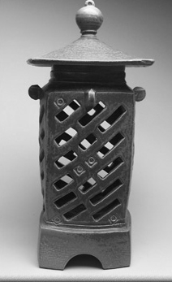

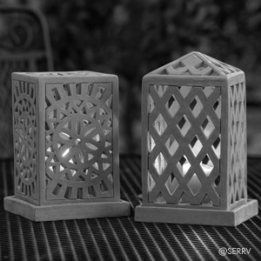
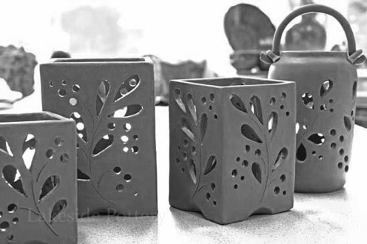

 | A | B | C | D-F
Structure | The slab structure is stable and extremely well connected. Walls are consistent and straight. | The slab structure is stable and well connected. Walls are mostly consistent and straight. | The slab structure is mostly stable and well connected. Walls are somewhat consistent and straight. | The slab structure is stable and well connected. Walls are consistent and straight.
Surface | The surface and inner shapes are extremely carefully smoothed. | The surface and inner shapes are carefully smoothed. | The surface and inner shapes are mostly carefully smoothed. | The surface and inner shapes are not carefully smoothed.
Overall Design | The overall design of the vessel and cutouts creates a very pleasing aesthetic effect. | The overall design of the vessel and cutouts creates a pleasing aesthetic effect. | The overall design of the vessel and cutouts creates a somewhat aesthetic effect. | The overall design of the vessel and cutouts does not create a very pleasing aesthetic effect.

