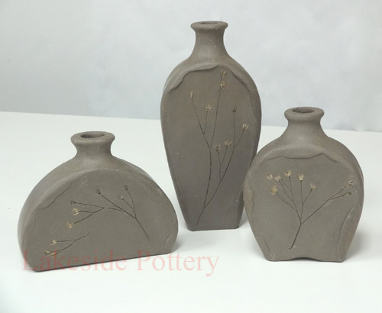
Slab Vessel
Name: ______________________

1. Draw 3 thumbnails to decide on a design (Final piece will be 11” tall)

2. Draw your chosen shape on a life size sheet of paper

 | A | B | C | D-F
Planning | 3 thumbnails were thoughtfully completed to explore the type of form to be constructed. | 3 thumbnails were somewhat thoughtfully completed to explore the type of form to be constructed. | 3 thumbnails were completed to explore the type of form to be constructed. | 3 thumbnails were not thoughtfully completed to explore the type of form to be constructed.
Construction | Attached parts are secure, lids and handles are sturdy. The proper joining procedures were followed. Clay walls and bottom are an appropriate thickness. | Attached parts are secure, lids and handles are sturdy. The proper joining procedures were followed. Clay walls and bottom are an appropriate thickness. | Attached parts are secure, lids and handles are sturdy for the most part. The proper joining procedures were mostly followed. Clay walls and bottom are not quite an appropriate thickness. | Attached parts are not secure, lids and handles are not sturdy. The proper joining procedures were not followed. Clay walls and bottom are not an appropriate thickness.
Form & Surface Quality | The pot was designed and constructed to be a unique design. It demonstrates symmetrical or asymmetrical balance. This grade also reflects the surface quality (smooth or controlled texture) | The pot was designed and constructed to be a mostly unique design. It mostly demonstrates symmetrical or asymmetrical balance. This grade also reflects the surface quality (smooth or controlled texture) | The pot was designed and constructed to be a somewhat unique design. It somewhat demonstrates symmetrical or asymmetrical balance. This grade also reflects the surface quality (smooth or controlled texture) | The pot was not designed and constructed to be a unique design. It does not demonstrate symmetrical or asymmetrical balance. This grade also reflects the surface quality (smooth or controlled texture)

Thumbnails

