Name: ______________________________

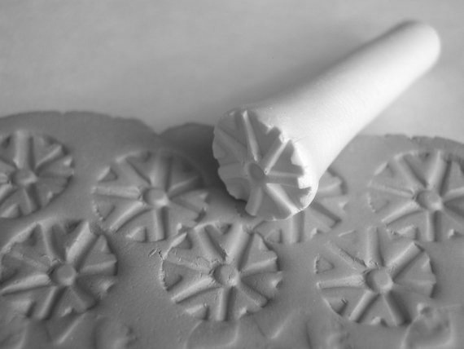
Stamping Fish & Pouring Vessel

Creating your Stamp
You will be creating at least 5 stamps that look like the one pictured on the right. Consider raised areas vs. indented areas to create an interesting design.
You need to complete a stamp for each one of the following:

- Circular, Radial Pattern
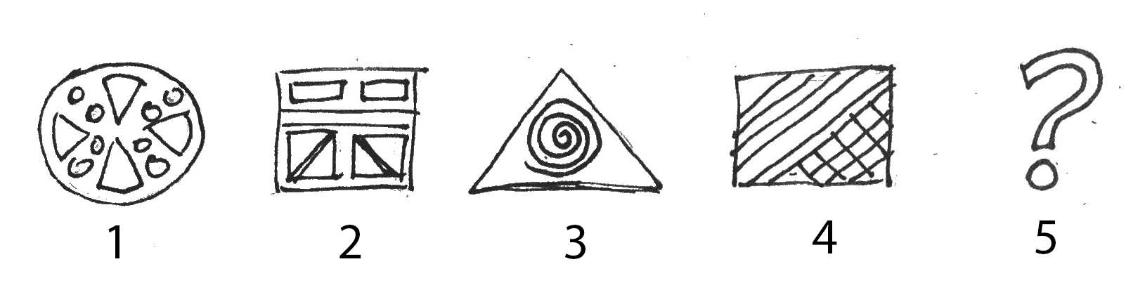
- Square, Symmetrical Pattern
- Triangular pattern
- Pattern using Lines
- Your Choice

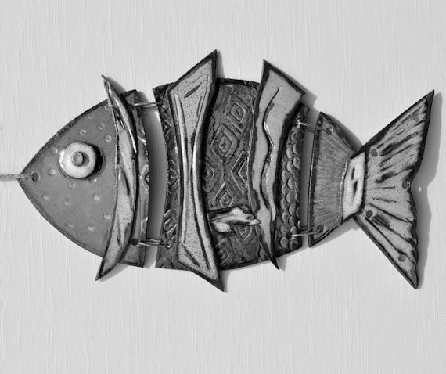

Creating your Fish
Use the attached pattern as a guideline for creating your fish. The fish should be created in 3 pieces to be attached by wire. Use your choice of the stamps you made to create texture on your fish.

Creating your Stamped Pouring Vessel
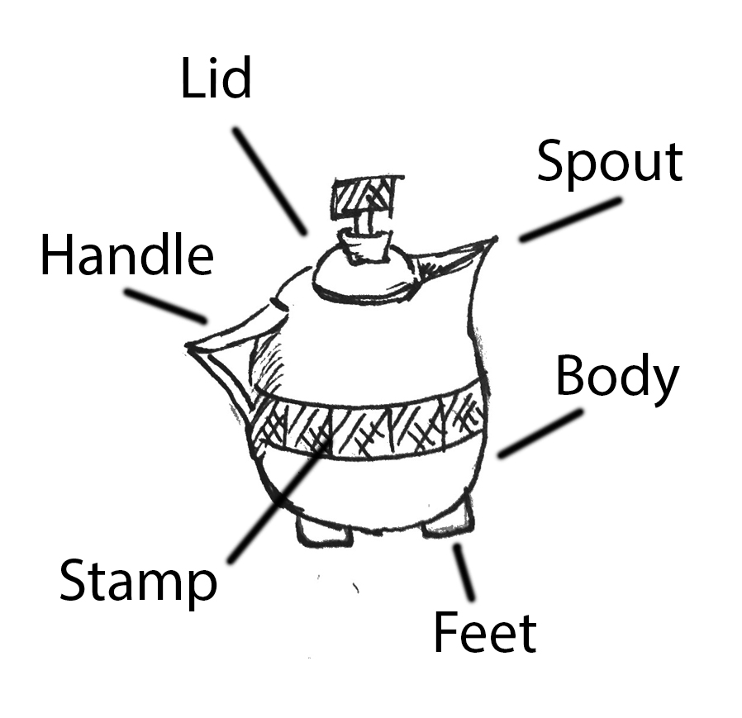
Choose to create a pitcher or teapot as your final project. You use at least one of your stamps to inspire your design. You must include the following parts:
- Body
- Spout
- Lid
- Feet
- Handle
Consider how your stamp can inspire the design. The one pictures to the right is inspired by stamp #4.

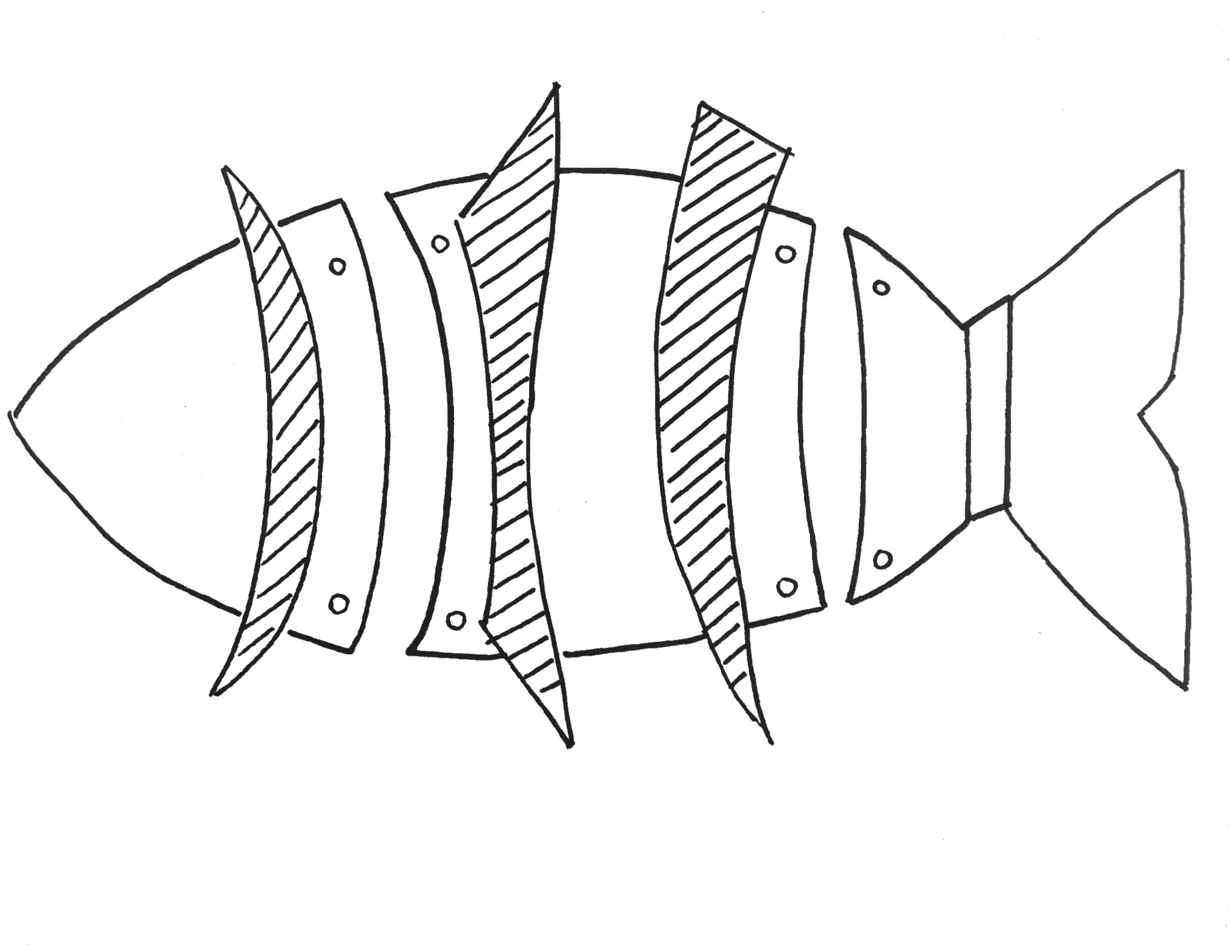
Fish Design

Stamp Pouring Vessel Designs

Stamped Fish Rubric
Fish Design | The design of the fish is unique but stays within size and design limitations. | The design of the fish is mostly unique but stays within size and design limitations. | The design of the fish is somewhat unique but stays within size and design limitations. | The design of the fish is not unique and may or may not stay within size and design limitations.
Stamps/ Textures | Stamps were completed with thought and unique design and were applied in an appropriate and interesting manner. | Stamps were mostly completed with thought and unique design and were applied in an appropriate and interesting manner. | Stamps were somewhat completed with thought and unique design and were mostly applied in an appropriate and interesting manner. | Stamps were not completed with thought and unique design and were not applied in an appropriate and interesting manner.
Overall Ceramic Craft | Coil or slab building techniques were completed with care and attention to cracks and smoothness. | Coil or slab building techniques were mostly completed with care and attention to cracks and smoothness. | Coil or slab building techniques were somewhat completed with care and attention to cracks and smoothness. | Coil or slab building techniques were not completed with care and attention to cracks and smoothness.

Stamped Pouring Vessel
Vessel Design | The design of the vessel is unique with a unique sense of inspiration from the stamp. | The design of the vessel is mostly unique with a unique sense of inspiration from the stamp. | The design of the vessel is unique with some sense of inspiration from the stamp. | The design of the vessel is not unique with little sense of inspiration from the stamp.
Stamps/ Textures | Stamps were completed with thought and unique design and were applied in an appropriate and interesting manner. | Stamps were mostly completed with thought and unique design and were applied in an appropriate and interesting manner. | Stamps were somewhat completed with thought and unique design and were mostly applied in an appropriate and interesting manner. | Stamps were not completed with thought and unique design and were not applied in an appropriate and interesting manner.
Overall Ceramic Craft | Coil or slab building techniques were completed with care and attention to cracks and smoothness. | Coil or slab building techniques were mostly completed with care and attention to cracks and smoothness. | Coil or slab building techniques were somewhat completed with care and attention to cracks and smoothness. | Coil or slab building techniques were not completed with care and attention to cracks and smoothness.
Use of Time and Challenge | The piece created is a representation of the knowledge and skill the student has regarding ceramics. The student created a unique design challenge for him or herself and followed through by using all time provided. | The piece created is a representation of the knowledge and skill the student has regarding ceramics. The student created a design challenge for him or herself and followed through by using all time provided. | The piece created is a representation of the knowledge and skill the student has regarding ceramics. The student created somewhat of a design challenge for him or herself and followed through by using all time provided. | The piece created is not a representation of the knowledge and skill the student has regarding ceramics. The student did not create a unique design challenge for him or herself and did not follow through by using all time provided.

