Stylized Object
Visual Communications
Name: _______________________________
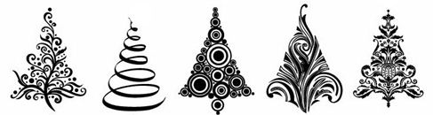

In this project, you will be choosing an object silhouette and using it as a guide to come up with 12 different styles. Choose an object with a very recognizable silhouette such as: scissors, hanger, key, snail, teapot, bicycle, footprint, feather, etc. The following is a list of styles you need to work with to come up with a total of 12 designs.

- Geometric
- Organic
- Linear
- Textured
- Economy (minimal)
- Playful/ Childlike
- Feminine
- Masculine
- Your Choice
- Your Choice
- Your Choice
- Your Choice

 | A | B | C | D-F
OVERALL EFFECT/ DESIGN | Each design is carefully balanced to be a stand alone design as well and are in accordance to the elements and principles. The overall collection is cohesive. | Each design is balanced to be a stand alone design as well and are in accordance to the elements and principles. The overall collection is mostly cohesive. | Designs are mostly balanced to be a stand alone designs as well and are mostly in accordance to the elements and principles. The overall collection is somewhat cohesive. | Each design is not carefully balanced to be a stand alone design as well and most designs are not in accordance to the elements and principles. The overall collection is not cohesive.
ILLUSTRATOR TECHNIQUE | The pen tool was used properly to create detailed shapes. | The pen tool was mostly used properly to create detailed shapes. | The pen tool was used somewhat properly to create detailed shapes. | The pen tool was not used properly to create detailed shapes.
ATTENTION TO STYLES | Individual styles show specific details and attention to the list provided. | Individual styles mostly show specific details and attention to the list provided. | Individual styles show some specific details and attention to the list provided. | Individual styles show little to no specific details and attention to the list provided.

