Name: _____________________________

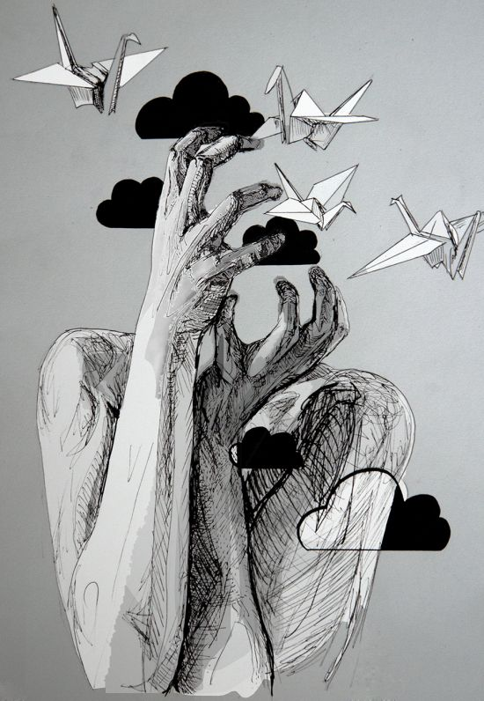**Subtractive Nature Portrait**

**Requirements:**

In this assignment, you will create Subtractive Nature Portrait that includes the following:

* Well planned asymmetrical composition (with attention to negative space)
* Fully shaded face/ body with possible partially shaded or faded areas
* 3 or more natural elements
* Painted background that works in harmony with the piece

**Process:**

1. Create at least 2 rough thumbnail drawings (4 x 5) of your initial ideas while browsing the provided images
2. Take portrait photos. Print an 8 x 10 and cut to SUBTRACT parts of the portrait. Print Nature Elements to cut out and insert in collage.
3. Grid your 8 x 10 Collage (1”). Grid your paper (2.5”) 20 x 25 Sketch the portrait in detail.
4. Render drawing with 9XXB pencil.
5. Paint final background with gray acrylic- take care to leave a generous edge and not cut and not the drawing.

**Rubric**

|  |  |  |  |  |
| --- | --- | --- | --- | --- |
|  | **A** | **B** | **C** | **D-F** |
| **Asymmetrical Composition** | The work is a balanced, asymmetrical piece with attention to placement of negative space. There is an outstanding overall effect due to attention to the balance of the painted element, non-rendered areas in balance with areas of full value. | The work is a balanced, asymmetrical piece with attention to placement of negative space. There is a good overall effect due to attention to the balance of the painted element, non-rendered areas in balance with areas of full value. | The work is a somewhat balanced, asymmetrical piece with some attention to placement of negative space. There is some quality overall effect due to attention to the balance of the painted element, non-rendered areas in balance with areas of full value. | The work is not a balanced, asymmetrical piece and has little attention to placement of negative space. There is a poor overall effect due to little attention to the balance of the painted element, non-rendered areas in balance with areas of full value. |
| **Portrait Value** | There is a full range of value and technique in the portrait rendering. | There is a mostly full range of value and technique in the portrait rendering. | There is a range of value and technique in the portrait rendering. | There is little to no range of value and technique in the portrait rendering. |
| **Natural Elements Value** | There is a full range of value and technique in the natural elements rendering. | There is a mostly full range of value and technique in the natural elements rendering. | There is a range of value and technique in the natural elements rendering. | There is little to no range of value and technique in the natural elements rendering. |
| **Overall Theme/ Content Effect** | There is a moving message or powerful synthesis of shapes to create an outstanding work. | There is a message or synthesis of shapes to create a successful work. | There is some message or some synthesis of shapes to create a successful work. | There is little to no message or synthesis of shapes to create a successful work. |