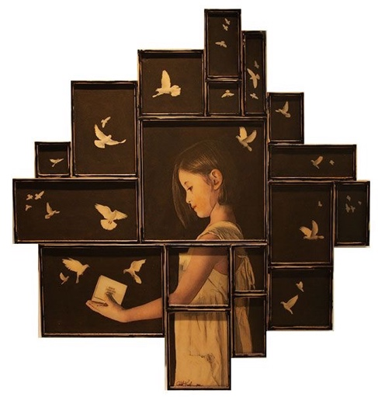
Need $3 for a half sheet of matboard or $6 for a full sheet

Painting 2 & 3
Cardboard Figure with Symbolism

We will be looking at the idea of Symbolism and choosing an object to create a story/ interest in the work. There will be an interaction between the object and a figure. We will study the work of Judith Kindler.

What you need:
- A photo of a figure*
- Photo(s) of a symbol*
- Thumbnail design with cardboard panels
*Photos need to be original!
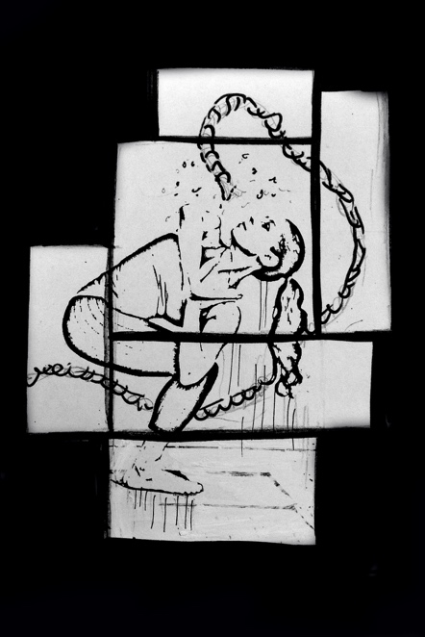
Media:
- Cardboard panels (can be torn)
- White gesso (areas, splatters, white accents)
- gray watercolor

Process:

Thumbnail
- Take photos of figure & symbols
- Turn photos to black and white and adjust contrast
- PRINT figure full page or more.
- Use pieces of cardboard to create an arrangement and place your printed figure overtop. Then, using this as a reference, sketch your overall thumbnail idea including figure, cardboard panels, and object(s)

Project & Working with Media
- Finalize location of panels and then transfer figure to panels. Freehand draw on object(s)
- Choose area to prep with gesso
- Watercolor the image
- Finish with any gesso that needs to go on top

 | A | B | C | D-F
Image Construction/ Originality & Content | The image was carefully constructed with attention to the figure’s details & position. There was thought in originality & symbolism in the design of the work. | The image was mostly carefully constructed with attention to the figure’s details & position. There was some thought in originality & symbolism in the design of the work. | The image was somewhat carefully constructed with attention to the figure’s details & position. There was some thought in originality & symbolism in the design of the work. | The image was not carefully constructed. There is little attention to the figure’s details & position. There is little thought in originality & symbolism in the design of the work.
Watercolor Technique | Watercolor technique was carefully applied with attention to value, washes, and style. | Watercolor technique was mostly carefully applied with attention to value, washes, and style. | Watercolor technique was somewhat carefully applied with attention to value, washes, and style. | Watercolor technique was not carefully applied with attention to value, washes, and style.
Overall Effect & Detail | There is a strong overall effect with the combination of texture rendering, balance, technique, and detail. | There is an overall effect with the combination of texture rendering, balance, technique, and detail. | There is some overall effect with the combination of texture rendering, balance, technique, and detail. | There is little to no strong overall effect with the combination of texture rendering, balance, technique, and detail.

Symbols

Anchor: hope; steadfastness; stability; tranquility
Apple: fertility; love; joyousness; knowledge; wisdom; luxury; deceitfulness; death
Apron: craftsmanship; fertility
Bag: secrecy; containing; hiding
Basket: attributes of the seasons and symbolize offerings of first fruits
Bee: immortality; rebirth; industry; order; purity; a soul
Belt: binding to power or office; dedication; fulfillment; victory; virtue; strength
Blindness; blindfolding: ignorance; sin; neglect of duty; failure to see the light and the right path
Bones: the indestructible life principle; the essential
Book: wisdom, scholarship
Bottle: principle of containing and enclosure
Box: containing
Bread: life, good of body
Buckle: protection
Buttons: can symbolize moon and stars
Cards: deck of fifty two cards symbolize weeks of the year, two red suits indicate the warm seasons and powers of light; two black are the cold seasons and powers of darkness. All four designs are life symbols: spade=leaf, heart=life, diamond=woman, club=man.
Cherry: blessed, good work, sweetness
Circle: totality, wholeness
Comb: fertility, rain, rays of the sun, entanglement, music
Corn: fertility of the earth, awakening life
Feather: truth, which must rise; lightness, dryness, height, speed, space, flight
Flute: anguish, extremes of emotion
Fruit: immortality, the result of one state and the seed of the next
Glove: evidence of good faith; purity of heart
Hammer: masculine force
Iron: durability, strength
Key: an axial symbol which includes all powers of opening and closing
Knot: binding, restraining, but also uniting; loosening knots- freedom, solving of problems
Leaf: fertility, growth; renewal
Mask: protection; concealment; transformation
Mirror: truth; wisdom; mind
Padlock: longevity; good health
Pear: hope; good health
Plants: life force
Rope: it both binds and limits yet provides the possibility of extension and freedom
Shoe: authority, liberty, lowly and humble
Tablet: the recording of past deeds and the future
Umbrella: solar disk or wheel, its spokes are the rays of the sun and its haft the world axis; power; shelter

Artist Study: Judith Kindler

Judith Kindler is an American multidisciplinary artist working in sculpture, installation, photography, and photography-based mixed media works. She is noted for her use of diverse and complex medias in the expression of a conceptual or narrative idea.
Born in Western New York, she grew up artistically under the influence of the New York Avant Garde. The frequent moves through the course of her adult life due to her work in the Applied Arts required her to have extended stays or to live in New York, New Orleans, Los Angeles, San Francisco, India and Italy and ultimately settling in the Northwest where she resides today. These places have had a tremendous impact in informing and influencing her art and can be seen woven throughout her work over time. Although she studied classical painting, sculpture and photography, she has always been drawn to experiment with new media and thus came to develop her own unique combinations of medias by the time she focused solely on her art in the 1990's.
Her work reveals both conscious and unconscious thoughts typically in response to current or past events that have impacted her life on a personal level, or as she interprets the greater impact to the overall social community and popular culture. Through an implied narrative and story telling, the artist explores the psychological and the human threads common to us all and reflected through the focused lens of a place, a time or a human experience or expression.

What do the curators and critics say about Kindler’s art:
Peter Frank, renowned American art critic and Huffington Post contributor writes:
“With her painting background, Judith Kindler appreciates the urgency that physicality gives imagery, and she has set out to explore the place where the picture becomes substance and its sway over us becomes substantial. In this, Kindler follows – in her own fashion – a tradition of “re-materiality” limned a hundred years ago by Dada artists..”
Kindler’s work in encaustic was described by Stefano Catalani, Artistic Director and Curator of the Bellevue Arts Museum in the exhibition book entitled “Defining Truth / Judith Kindler”: “The composition of the photographs is minimal, reduced to standing girls and young women in white delicate clothing, often against an indefinite and blurred background. The spatial perception here is blind, almost dimensionless, except for the human figure. The white atmosphere is rarefied, suspended, though charged at times with symptoms of tension: A sudden gesture of embrace, eye contact with the viewer, lifted hands, or eyes cast down . . . Judith Kindler builds up the narrative and iconographic space . . . a repertoire of symbols and seminal ideas projected out for readers able to decipher.”

Name: _____________________________
Artist Study: Judith Kindler
Questions

After viewing some pieces by Judith Kindler and reading her Artist statement and watching the video, answer the following questions:

Narrative art is art that tells a story, either as a moment in an ongoing story or as a sequence of events unfolding over time. Some of the earliest evidence of human art suggests that people told stories with pictures

- In the video, Judith Kindler explains her work is a narrative for the viewer to decipher. She says “I leave clues.” What do you think she mean by this?

- In the artist statement, it says that Kindler “explores the psychological and the human threads common to us all.” What do you think that means?

- In the video, Kindler talks about the “subtleties” in her work… parts that do not look like they were done by a machine. This could be a splatter or a drip that makes the work “imperfect.” Why would “subtleties” be particularly important to Kindler’s artwork?

