Technology Connections Figure in Pen & Ink

Preparing your Full Figure Image
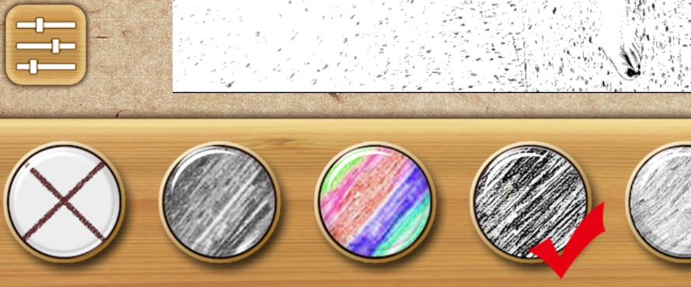
- Take a photograph from above of a full figure lying on the floor. Pay attention to clothing and decide whether the figure will be falling or contorted. The pose should be overemphasized: really move arms and legs to create a dramatic effect.
- Use PhotoPal to change your photo to black and white. Open the photo in the SketchMe app and choose this setting.
- Print a 5 x 7 with the figure cropped how you would like (figure need to remain a full figure but a small bit of cropping would be fine)
- Cut out your figure to remove background items and place on a new 5 x7 piece of paper. This will be your thumbnail drawing.

Technology Research & Planning
- Search the web to collect ideas for symbols and imagery related to our ever-changing technological world. Remember you should not copy directly from photos and clip art that are copyrighted. Use as inspiration and change as necessary.
- Sketch your items onto your thumbnail drawing to create a composition.
How to make a successful asymmetrical composition:
- Draw your biggest shape first
- Don’t Center
- Overlap and Repeat
- Allow shapes to go off the edge
- Vary sizes
  - Consider your choices for symbols and what the piece’s content may be.
  - Consider CONTRAST: placement of darker, filled in objects in certain areas to attract attention and create balance.
  - Consider items that help make a successful asymmetrical composition:

Pen & Ink
- The final thumbnail will be projected and lightly sketched. It will need to be finalized with straight lines and details.
- Pen & Ink will be used as the media with pointillism and crosshatching being the main techniques.

Rubric

 | A | B | C | D-F
Design & Composition Originality | The composition and design is carefully planned to create a balanced asymmetrical composition. Symbols are not copied and are assembled thoughtfully to express meaning. | The composition and design is mostly carefully planned to create a balanced asymmetrical composition. Symbols are not copied and are assembled thoughtfully to express meaning. | The composition and design is somewhat carefully planned to create a balanced asymmetrical composition. Symbols are not copied and are assembled thoughtfully to express meaning. | The composition and design is not carefully planned to create a balanced asymmetrical composition. Some or all symbols are copied and are not assembled thoughtfully to express meaning.
Pen & Ink Technique | Pen techniques were carefully applied and controlled. | Pen techniques were mostly carefully applied and controlled. | Pen techniques were somewhat carefully applied and controlled. | Pen techniques were not carefully applied and controlled.
Value & Contrast | Value and contrast were fully utilized. There are areas of pure white and areas of black with a large variety of shades in between. | Value and contrast were utilized. There are areas of pure white and areas of black with several shades in between. | Value and contrast were somewhat utilized. There are some areas of pure white and areas of black with a large variety of shades in between. | The value range is very poor.

