Texture Silhouette
Name: ______________________________________

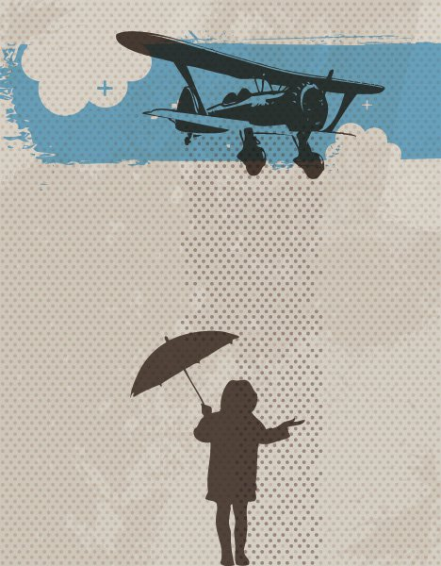
In this project you will combine a silhouette with a texture background.

Set up your document as 6” x 10”
- Look through options for textures/brushes in the Libraries provided
- Find a silhouette photo(s) to combine to create an original image. Create a thumbnail idea looking at your silhouette image and your options for textures/brushes.
- Create image in Illustrator. The following are some things to consider:
  - Use minimal color
  - Utilize negative space
  - You can use a transparent color overtop of your textures to tint them
  - You can use a brush with your matching background color overtop of a shape to give it a grunge/texture look

 | A | B | C | D-F
Design/ Color/ Negative Space | The overall design, color, and use of negative space create an interesting and balanced composition. | The overall design, color, and use of negative space create an interesting and mostly balanced composition. | The overall design, color, and use of negative space create a somewhat interesting and balanced composition. | The overall design, color, and use of negative space do not create an interesting and balanced composition.
Textures | Textures were carefully chosen and worked with to complement/ interact with the silhouette images. | Textures were mostly carefully chosen and worked with to complement/ interact with the silhouette images. | Textures were somewhat carefully chosen and worked with to complement/ interact with the silhouette images. | Textures were not carefully chosen and worked with to complement/ interact with the silhouette images.
Illustrator Technique | The pen tool was used properly to create detailed shapes. | The pen tool was mostly used properly to create detailed shapes. | The pen tool was used somewhat properly to create detailed shapes. | The pen tool was not used properly to create detailed shapes.

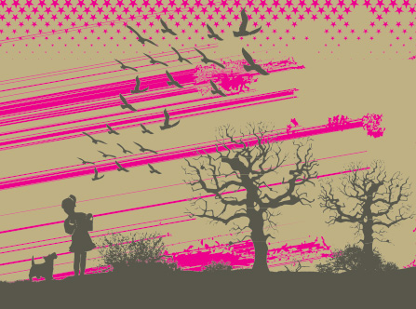
Illustrator Texture & Brushes
- Window
- Swatch Libraries
- Patterns
- Basic Graphics
  - Dots
  - Lines
  - Textures

- Window
- Symbol Libraries
- Dot Pattern Vector Pack

- Window
- Brush Libraries
- Artistic

- Window
- Brush Libraries
- Vector Packs
  - Grunge Brushes Vector Pack
  - Hand Drawn Brushes Vector Pack

Thumbnails

Texture Silhouette Critique
Name: ________________________

- What is the focal point and why?

- Describe the use of line in the piece:

- Describe the Negative Space:

- The artist chose to use blue in only one selective area. Describe why you think this choice was made and how it impacts the overall piece.

- Describe the eye movement around the piece.

- In what ways does the use of texture/pattern impact the work?

- Describe the proportions of the object in this work. Would you change anything and why?

- What is repeated in this piece and how does it impact the overall effect?

- Describe the type of balance used in this work and how it is achieved:

