Things to Consider when Choosing a Photo:
- Composition (the subject cannot be in the center)
- Background (must have one… nothing plain)
- Values (full range)
- Resolution (no pixels; find a CLEAR image)
- Rectangular format
- Must be a real photograph (not a drawing or painting)

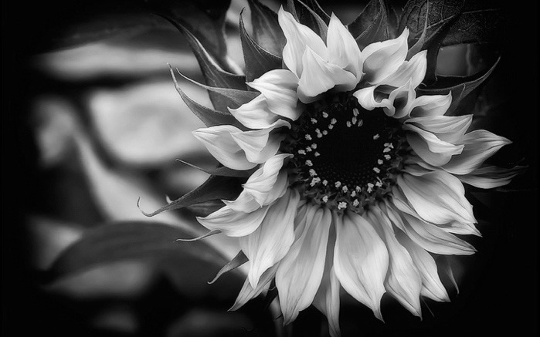
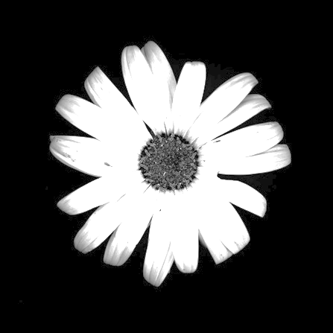

Things to Consider when Choosing a Photo:
- Composition (the subject cannot be in the center)
- Background (must have one… nothing plain)
- Values (full range)
- Resolution (no pixels; find a CLEAR image)
- Rectangular format
- Must be a real photograph (not a drawing or painting)

