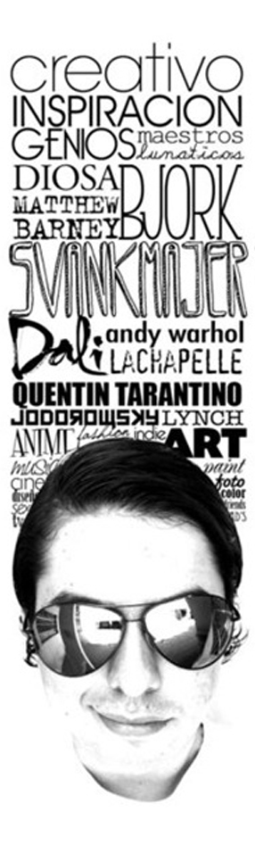
Typography Portrait

- Take a portrait photo and open in Photoshop. Use the stamp filter to help make the image vector.
- Brainstorm a list of creative adjectives about yourself. Use a thesaurus to help make your words more interesting. You can describe your characteristics and/or physical appearance.
- Use the fonts in Illustrator to create an interesting composition with attention to the alignment. You may also look on fontspace.com or letteringdelights.com

 | A | B | C | D-F
Font and Word Choice | Fonts and words were carefully chosen and paired for effectiveness. | Fonts and words were mostly carefully chosen and paired for effectiveness. | Fonts and words were somewhat carefully chosen and paired for effectiveness. | Fonts and words were not carefully chosen and not paired for effectiveness.
Technical Quality | All words are carefully aligned and not distorted. | All words are mostly carefully aligned and not distorted. | All words are somewhat carefully aligned and not distorted. | All words are not carefully aligned and some are distorted.
Overall Effect & Composition | There is an overall sense of balance and harmony and attention to the relationship between the portrait and the words. | There is mostly an overall sense of balance and harmony and attention to the relationship between the portrait and the words. | There is some overall sense of balance and harmony and attention to the relationship between the portrait and the words. | There is little overall sense of balance and harmony and attention to the relationship between the portrait and the words.

