Name : ________________________

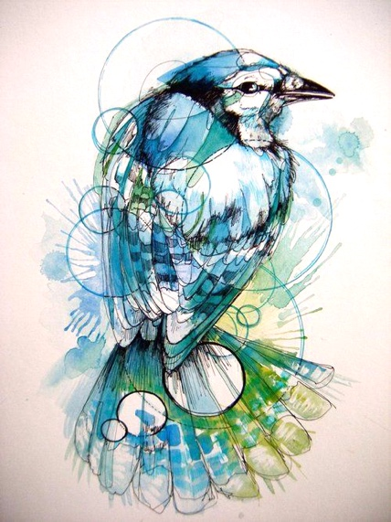
Watercolor Birds

- Choose a Bird STYLE and print
- Choose a bird image. Zoom in on your bird and print full page.
- Lay a piece of transparency paper over the bird image and draw your geometric stylized shapes overtop in sharpie.
- Give the transparency to teacher to be copied (enlarged)
- Use enlarged drawing to transfer to large watercolor paper
- Sharpie design
- Mix sample of all colors shown in STYLE. Transfer parts of bird to scrap watercolor paper. Practice colors, washes, splotches, straw blow, salt, spatter, etc.
- Complete actual painting

Rubric
 | A | B | C | D-F
Bird Design (Sharpie) | Use and integration of geometric shapes and use of texture with pen techniques is highly effective. | Use and integration of geometric shapes and use of texture with pen techniques is effective. | Use and integration of geometric shapes and use of texture with pen techniques is somewhat effective. | Use and integration of geometric shapes and use of texture with pen techniques is not effective.
Watercolor Technique/ Value | All watercolor techniques used were done correctly. The piece has a full range of values. | Watercolor techniques used were mostly done correctly. The piece has a full range of values. | All watercolor techniques used were done somewhat correctly. The piece mostly has a full range of values. | Watercolor techniques used were not done correctly. The piece has a small range of values.
Bird Design (Watercolor)/ Overall Effect | Special techniques such as washes, splotches, straw blow, salt, spatter, etc. were used carefully and effectively. There is a careful study and use of color to create an overall balanced effect. | Special techniques such as washes, splotches, straw blow, salt, spatter, etc. were used effectively. There is mostly careful study and use of color to create an overall balanced effect. | Special techniques such as washes, splotches, straw blow, salt, spatter, etc. were used somewhat effectively. There is some use of color to create an overall balanced effect. | Special techniques such as washes, splotches, straw blow, salt, spatter, etc. were used mostly ineffectively. There is little study and use of color to create an overall balanced effect.

