Name: _______________________

Watercolor Pasta
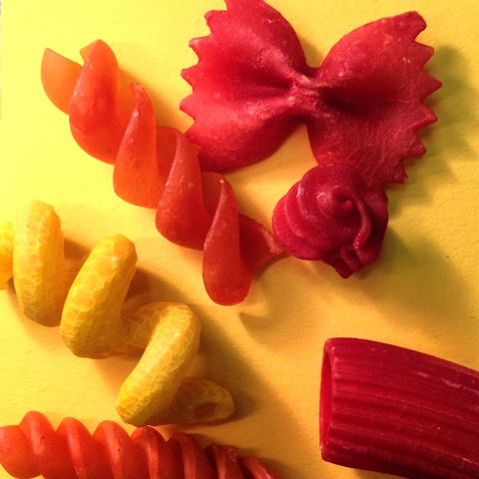
- Choose either a Warm or Cool color scheme.
- Ex. If you choose Warm, all your pasta and background color should only be warm colors

- Create a composition with the pasta on your 2.5 inch paper. Try to use the pasta to direct the eye to a focal point

- Photograph using the SQUARE setting. Use the spotlight to create more shadows.

- Open in PhotoPal and adjust levels.

- Open in PhotoPrint and Print on Print Letter size—2 pages landscape—Fill up the width and print the top and bottom. Cut and tape image together.

- Use graphite to transfer to watercolor paper: 11.5 x 11.5

- Practice: Sketch a couple pieces of pasta on practice watercolor paper, remember to use masking fluid first and work back to front.

USE COMPLEMENTARY COLORS TO HELP SHADE!

When practice is complete, begin real project.

 | A | B | C | D-F
Drawing | The piece is drawn with correct proportions and detail. | The piece is drawn with mostly correct proportions and detail. | The piece is drawn with some correct proportions and detail. | The piece is drawn with poor proportions and detail.
Watercolor Technique | The piece exhibits strong use of watercolor technique and skill. | The piece exhibits good use of watercolor technique and skill. | The piece exhibits some good use of watercolor technique and skill. | The piece exhibits little use of watercolor technique and skill.
Values/ Color | The piece has a full range of values and pushes shadows and highlights. One color plus it’s complement was used. | The piece mostly has a full range of values and pushes shadows and highlights. One color plus it’s complement was used. | The piece has some range of values. One color plus it’s complement was used. | The piece has few values. One color plus it’s complement may not have been used.

