Name: __________________
Watercolor Roundscape

In this assignment, you will be designing a “Roundscape”—a landscape inside a circle format. Your landscape must include:
- At least 3 layers
- A focal point
- Color Scheme
- Atmospheric perspective: the technique of creating an illusion of depth by depicting distant objects as paler, less detailed, and usually bluer than near objects.

 | A | B | C | D-F
DESIGN | There is outstanding attention to balance and an asymmetrical focal point, interesting textures, and a cohesive combination of images to create depth. | There is attention to balance and an asymmetrical focal point, interesting textures, and a cohesive combination of images to create depth. | There is some attention to balance and an asymmetrical focal point, interesting textures, and a cohesive combination of images to create depth. | There is little attention to balance and an asymmetrical focal point, interesting textures, and a cohesive combination of images to create depth.
WATERCOLOR TECHNIQUE | The amount of water used was varied. Paint was not laid down in an opaque fashion.  There is a variety of edges and highlights, soft vs. hard. | The amount of water used was somewhat varied. Some paint was laid down in an opaque fashion.  There is a variety of edges and highlights, soft vs. hard. | The amount of water used was rarely varied. Some paint was laid down in an opaque fashion.  There is some variety of edges and highlights, soft vs. hard. | The amount of water used was very rarely varied. Some paint was laid down in an opaque fashion.  There is little variety of edges and highlights, soft vs. hard.
COLOR SCHEME & VALUE | Color and value were carefully used to develop form and also to develop a finished composition. | Color and value were used to develop form and also to develop a finished composition. | Color and value were used somewhat to develop form and also to develop a finished composition. | Color and value were not used well to develop form and also to develop a finished composition.

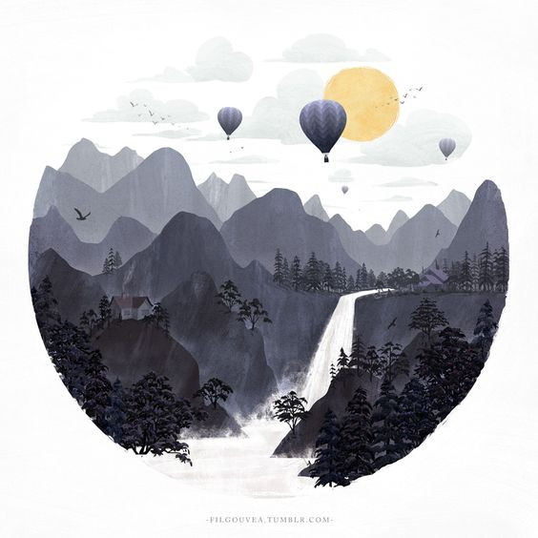
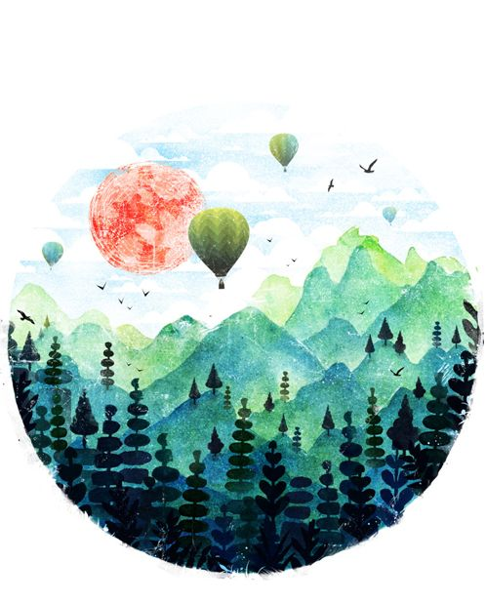
Figure 1 Use of many layers and filled space, Nearly monochromatic color scheme
Figure 1 Use of layers, comlementary color scheme, texture, focal point/ interest in balloons

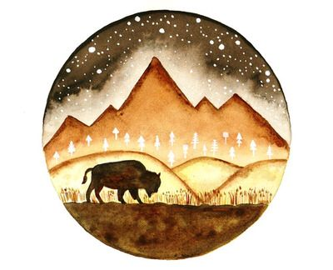
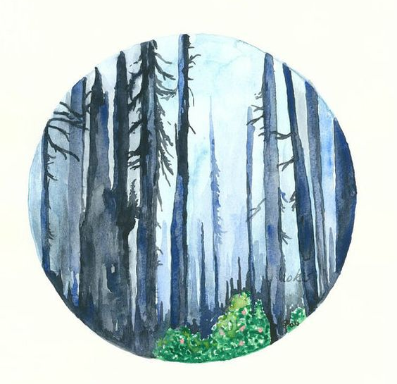
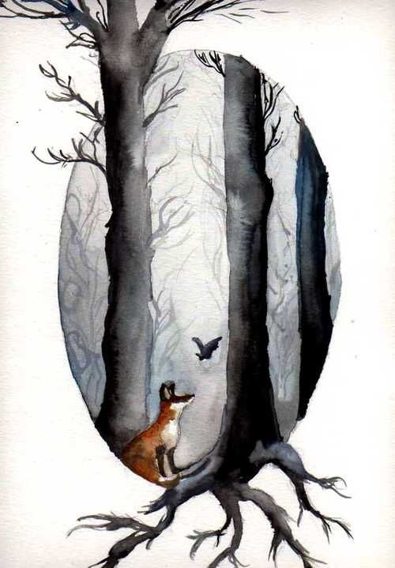
Figure 4 atmospheric perspective, linear qualities fill up the space
Figure 3 Focal point, analogous colors/ values, but very flat
Figure 3 imagery protrudes from circle, atmospheric elements, focal point

