Name: ________________________________
Watercolor Vocabulary/ Intro to Landscape

- ______________________________________finely ground, colored powders that form paint when mixed with liquid
- ______________________________________liquid that holds together grains of pigment

______________________________________For watercolor use, it ranges from 140 lb to 300 lb.

- ______________________________________mildly rough texture
- ______________________________________extremely smooth
- ______________________________________coarse texture

- ______________________________________color seen in the objective world (green grass, blue sky)
- ______________________________________color perceived by the viewer due to the effect of atmosphere or unusual light on the actual color
- ______________________________________color on an object that bounces off adjacent (nearby) objects

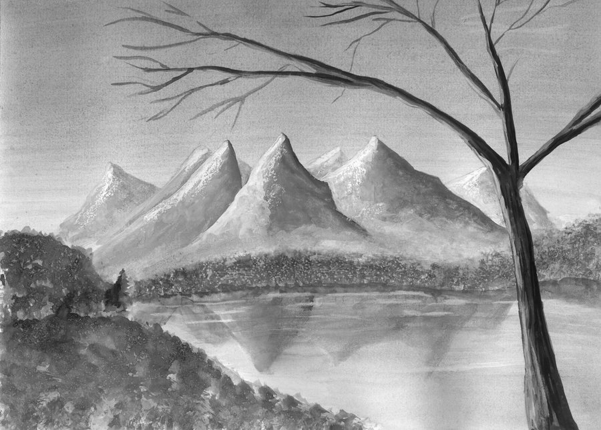
List the order in which you would paint this landscape:

What are the most important things you need to improve upon after doing the monochromatic watercolor?

Name: ________________________________
Watercolor Vocabulary/ Intro to Landscape

- ______________________________________finely ground, colored powders that form paint when mixed with liquid
- ______________________________________liquid that holds together grains of pigment

______________________________________For watercolor use, it ranges from 140 lb to 300 lb.

- ______________________________________mildly rough texture
- ______________________________________extremely smooth
- ______________________________________coarse texture

- ______________________________________color seen in the objective world (green grass, blue sky)
- ______________________________________color perceived by the viewer due to the effect of atmosphere or unusual light on the actual color
- ______________________________________color on an object that bounces off adjacent (nearby) objects

List the order in which you would paint this landscape:

What are the most important things you need to improve upon after doing the monochromatic watercolor?

Watercolor Techniques Vocabulary Review
- ________________tray for mixing colors of paint
- ________________any textured application of paint where your brush is fairly dry and you used the hairs of your brush, the angle of your stroke, and the paper's surface texture to create broken areas of paint. Used for texture such as stone, weathered wood, foliage, etc.
- ________________thin layer of paint covering a large area of the support
- ________________laying new wet color over a dried layer below
- ________________any area of a painting where a wash of a single color and value is painted in a series of multiple, overlapping strokes.
- ________________any transparent wash of color laid over a dry, previously painted area. Used to adjust color, value, or intensity of underlying painting
- ________________when your fresh brush stroke hits a still damp wash, it will force the original wash out in an irregular, often fractal manner
- ________________using an absorbent material such as tissues or paper towels, or a squeezed out brush to pick up a wet wash
- ________________a wash that smoothly changes in value from dark to light. Most noted in landscape painting for open sky work, but an essential skill for watercolor painting in general
- ________________a latex gum product that is used to cover a surface you wish to protect from receiving paint
- ________________laying a new color before the previous one has dried
- ________________a wet wash created by blending a variety of discrete colors so that each color retains its character while also blending uniquely with the other colors in the wash

back runs
blotting
dry brush
flat wash
glazed wash
graded wash
masking fluid
palette
variegated wash
wash
wet-on-dry
wet-on-wet
Watercolor Techniques Vocabulary Review
- ________________tray for mixing colors of paint
- ________________any textured application of paint where your brush is fairly dry and you used the hairs of your brush, the angle of your stroke, and the paper's surface texture to create broken areas of paint. Used for texture such as stone, weathered wood, foliage, etc.
- ________________thin layer of paint covering a large area of the support
- ________________laying new wet color over a dried layer below
- ________________any area of a painting where a wash of a single color and value is painted in a series of multiple, overlapping strokes.
- ________________any transparent wash of color laid over a dry, previously painted area. Used to adjust color, value, or intensity of underlying painting
- ________________when your fresh brush stroke hits a still damp wash, it will force the original wash out in an irregular, often fractal manner
- ________________using an absorbent material such as tissues or paper towels, or a squeezed out brush to pick up a wet wash
- ________________a wash that smoothly changes in value from dark to light. Most noted in landscape painting for open sky work, but an essential skill for watercolor painting in general
- ________________a latex gum product that is used to cover a surface you wish to protect from receiving paint
- ________________laying a new color before the previous one has dried
- ________________a wet wash created by blending a variety of discrete colors so that each color retains its character while also blending uniquely with the other colors in the wash

back runs
blotting
dry brush
flat wash
glazed wash
graded wash
masking fluid
palette
variegated wash
wash
wet-on-dry
wet-on-wet

